


Cairo University
Faculty of Computers and Artificial Intelligence
Operations Research and Decision Support Department
Egyptian Premier League Schedule Optimizer
Graduation Project — Final Documentation
Submitted to the Faculty of Computers and Artificial Intelligence, Cairo University,
in Partial Fulfillment of the Requirements for the bachelor’s degree in
Operations Research and Decision Support
Academic Year 2025–2026
Under Supervision of:
Dr. Sally Kassem
Eng. Rawaa Hesham

Rawan Ehab 20220133
Mohamed Osama 20220477
Abd El-Rahman Ashraf 20220189
Ghassan Tarek 20220239
Ibrahim Medhat 20221003

ABSTRACT

The Egyptian Premier League scheduling process has evolved over time and is no longer entirely manual, and already considers multiple operational factors such as competition calendars, stadium availability, and security requirements. However, despite these improvements, the scheduling process still faces recurring challenges, including frequent postponements, uneven rest periods between teams, congestion caused by overlapping competitions, and difficulties in maintaining a standard league format within a fixed seasonal timeframe. These issues indicate that the existing scheduling approach lacks a unified optimization framework capable of evaluating all constraints and objectives simultaneously.
This project presents an optimization-based scheduling system using Constraint Programming with SAT solving (CP-SAT), implemented via Google OR-Tools to enhance the current scheduling process rather than replace it. The league season is modeled as a constrained optimization problem where matches are assigned to predefined calendar slots and venues while respecting competition rules, continental commitments, security constraints, and fairness considerations. The system was implemented using Python, where structured data inputs are combined with mathematical constraints and objective functions to systematically evaluate scheduling alternatives.
The optimizer minimizes a weighted penalty covering round-order deviation, weekly load balance, away-team travel distance, and match-tier vs. slot-tier alignment — ensuring high-profile fixtures are placed in prime-time broadcast slots. A dedicated post-baseline CAF audit and greedy repair phase detects and reschedules any matches that violate continental competition buffer rules.

TABLE OF CONTENTS

Contents
ABSTRACT 2
TABLE OF CONTENTS 3
LIST OF TABLES 8
CHAPTER 1 1
INTRODUCTION TO THE PROJECT REPORT AND PROJECT OVERVIEW 1
1 Introduction 2
1.1 Problem Domain 2
1.2 Problem Statement 3
1.3 Proposed System 4
1.3.1 Aims and Objectives 4
1.3.2 Proposed System Features 5
1.4 Development Methodology 6
1.5 Resource Requirement 6
1.6 Report Layout 7
CHAPTER 2 8
BACKGROUND/EXISTING WORK 8
2 Background 9
2.1 Introduction to Sports Scheduling 9
2.2 Theoretical Concepts 9
2.2.1 Patterns and Breaks 9
2.2.2 The Traveling Tournament Problem (TTP) 10
2.3 Mathematical Approaches 10
2.3.1 Integer Linear Programming (ILP) 10
2.4 Review of Existing Real-World Implementations 10
2.4.1 The Chilean First Division (The "Gold Standard") 10
2.5 The Egyptian Context: Gaps in Current Practice 11
CHAPTER 3A 12
PROJECT DATA AND DATA PREPROCESSING PHASES 12
3 Project data and data preprocessing 13
3.1 Data Collection 13
3.2 Data structure 14
3.2.1 Teams data 14
3.2.2 Stadium Data 15
3.2.3 Calendar Data 15
3.2.4 Security Matrix 16
3.2.5 Continental (CAF) Schedule 17
3.2.6 Distance Matrix Schema 17
3.2.7 Historical Benchmark Dataset 18
3.3 Data Preprocessing 19
CHAPTER 3B 21
MATHEMATICAL FORMULATION 21
3.4 Sets 22
3.5 Parameters 22
3.5.1 Match parameters 22
3.5.2 Slot parameters 23
3.5.3 Round parameters 23
3.5.4 CAF parameters 23
3.5.5 Capacity constants 23
3.5.6 Venue Parameters 24
3.6 Feasible Domain 24
3.7 Decision Variables 24
3.7.1 Primary assignment 24
3.7.2 Auxiliary time variables 25
3.7.3 Weekly load variables 25
3.7.4 Final-Round Slot variables 25
3.7.5 Collision Indicator Variables 26
3.8 Hard Constraints 26
3.9 Objective Function 30
3.10 Objective Weights 32
3.11 Model Summary 33
3.11.1 Hard constraints 33
3.11.2 Objective terms 33
SYSTEM DESIGN 34
4 System Architecture and Component Overview 35
4.1 Layers 35
4.2 Component Diagram 36
4.3 Deployment Architecture 36
4.4 Class / Module Diagrams 36
4.4.1 Key Data Structures Used by the Final Pipeline 37
Match (src/fixture_generator.py) 37
RoundWindow (src/slot_domain.py) 37
ScheduledMatch (src/baseline_solver.py) 38
RunMetrics (src/multi_run.py) 38
4.5 Sequence Diagrams (Key Use Cases) 38
4.5.1 Use Case: Run the Full Pipeline from the Streamlit UI 38
4.5.2 Use Case: Explore a Generated Schedule (Team Chooser) 39
4.5.3 Use Case: Inspect Schedule Quality (Insights Tab) 39
5 I Implementation Environment and Setup 42
5.1 Language, Runtime, and Core Libraries 42
5.2 Project Layout 43
5.3 Running the Project 43
5.4 Key Implementation Details 44
5.4.1 Fixture Generation: Circle Method + CP-SAT Orientation 44
5.4.2 Slot Domains and the CAF Rest-Day Rule 44
5.4.3 The Baseline CP-SAT Model 45
5.4.4 Domain-Fallback Retries and the Final-Round Rescue Model 46
5.4.5 Post-Solve Validation 47
5.4.6 Streamlit Application: Caching and Non-Blocking Runs 47
5.5 Sample Screenshots / Output Samples 48
51
5.6 Final Schedule Output (optimized_schedule.csv) 51
6 Testing 53
6.1 Testing strategy 53
6.1.1 Build-Time Structural Assertions 53
6.1.2 Automated Post-Solve Validation 53
6.1.3 Manual / Exploratory Testing via the Dashboard 54
6.2 Test Cases and Results 54
6.3 Performance Evaluation / Benchmarking 56
6.3.1 Solver Performance 56
6.3.2 Evaluating Travel Efficiency 56
6.3.3 Stadium Utilization and Maintenance Overlaps 57
6.3.4 Benchmarking Against Historical Seasons 58
58
6.3.5 Benchmarking Across Seeds (Monte Carlo) 58
6.4 Limitations and Known Issues 59
6.4.1 Testing-Process Limitations 59
6.4.2 Application Limitations 59
7 Conclusion 61
7.1 Summary of Achievements 61
7.2 Lessons Learned 62
7.2.1 The Final Round Is a Source of Difficulty 62
7.2.2 Real Data Is Messier Than the Model Assumes 62
7.3 Future Enhancements 63
7.3.1 Multi-objective Pareto optimization 63
7.3.2 Metaheuristic hybridization 63
7.3.3 Weather and Ramadan awareness 63
7.3.4 Sensitivity analysis 63
7.3.5 API layer 63
7.3.6 League-agnostic configuration 63
7.3.7 Export to iCal/Google Calendar 63
8 References 64

LIST OF FIGURES

Figure 1: Team & Stadiums Relation Diagram 19
Figure 2:Dates Relationship Model 20
Figure 3 : System Component Diagram 36
Figure 4 : Class Diagram 37
Figure 5: Full Pipeline Use Case 38
Figure 6: Generated Schedule Use Case 39
Figure 7: Explore Insights Use Case 40
Figure 8: Sidebar 48
Figure 9: “Run & progress” tab mid-run 49
Figure 10: “Explore” tab — Team chooser 49
Figure 11: “Insights” tab — Overview sub-tab 50
Figure 12: “Explore” tab — Calendar sub-tab 50
Figure 13: Match Details Card 51
Figure 14: Output Format 51
Figure 15: Results Overview 56
Figure 16: Travel Fairness Insights 57
Figure 17: Stadiums & Venues Insights 57
Figure 18: Historical Results Comparison 58
Figure 19: Monte-Carlo results 59

LIST OF TABLES
Table 1: Teams Dataset Schema 14
Table 2: Stadiums dataset schema 15
Table 3: Calendar data schema 16
Table 4: Security Constraints Schema 16
Table 5:Continental (CAF) Schedule Schema 17
Table 6: Distance Matrix Schema 17
Table 7: Past Data schema 18
Table 8: Sets 22
Table 9: Match Parameters 22
Table 10: Slot Parameters 23
Table 11: Round Parameters 23
Table 12: CAF Parameters 23
Table 13: Capacity Constants 23
Table 14: Objective Weights 32
,Table 15: Hard Constraints 33
Table 16: Objectives 33
Table 17: Used Libraries 42
Table 18: Test Cases 55

CHAPTER 1

INTRODUCTION TO THE PROJECT REPORT AND PROJECT OVERVIEW

Introduction
Football competitions are complex systems that require careful planning and coordination between many parties, including teams, stadiums, broadcasters, and governing bodies. The Egyptian Premier League is one of the most followed sports competitions in the country and involves many matches played over a long season. Creating a league schedule that satisfies all operational requirements while maintaining fairness between teams is a challenging task known in the field of Operations Research as the "Sports Scheduling Problem” [1].

In recent years, the league scheduling process has improved and now considers several important factors such as competition calendars, stadium availability, and security requirements, notably through partnerships with specialized scheduling firms [2]. However, despite these developments, league seasons continue to suffer from delays, congestion, and frequent rescheduling due to external factors like CAF interruptions. These issues suggest that while the scheduling process exists, it is not fully optimized and does not always provide the best possible outcomes under complex constraints.
This project focuses on enhancing league scheduling using mathematical optimization techniques. By modeling the Egyptian Premier League as an optimization problem, we aim to generate a complete and balanced schedule that respects all constraints while fitting within a fixed seasonal timeframe. It demonstrates how structured optimization models can support decision-making in sports scheduling and improve the overall organization of league competitions.

Problem Domain
The problem domain of this project falls under sports scheduling optimization, which is a subfield of operations research and applied mathematics. Sports scheduling problems involve assigning matches to time slots and venues while respecting a wide range of constraints related to logistics, fairness, and competition rules.
In the context of the Egyptian Premier League, scheduling must account for domestic league matches, cup competitions, continental tournaments organized by CAF, international breaks, stadium sharing, and security considerations. Each of these factors imposes limitations on when and where matches can be played.
Additionally, teams differ in geographical location, stadium ownership, competitive importance, and participation in continental competitions. This leads to unequal travel demands and varying levels of schedule pressure across teams. Addressing these differences in a fair and systematic way places the scheduling problem firmly within the domain of constrained optimization rather than simple timetable generation.
Because of the large number of variables and constraints involved, this problem is well-suited for mathematical modeling approaches, specifically Constraint Programming with SAT solving (CP-SAT) that can evaluate many possible schedules and identify solutions that best satisfy defined objectives [3].

Problem Statement
Although the Egyptian Premier League scheduling process considers multiple constraints, it continues to experience structural issues that affect competition quality and fairness. The roots of this chronic instability can be traced back to the 2018/2019 season. When Egypt was selected as the emergency host for the 2019 African Cup of Nations (AFCON) replacing Cameroon, the domestic league was forced into a severe hiatus to facilitate stadium preparations. This disruption was soon followed by the global COVID-19 pandemic, which forced a four-month suspension of all football activities in 2020. The cumulative impact of these two consecutive shocks created a "domino effect" of delayed start dates and congested fixtures that the league has yet to fully recover from [4].
The core problem is the absence of a unified optimization framework that simultaneously considers all scheduling constraints and objectives. Existing approaches tend to address constraints individually, which can result in local solutions that create larger conflicts later in the season. As a result, league organizers are frequently forced to introduce exceptional arrangements that reduce competitive balance.
The problem addressed in this project is how to construct a complete Egyptian Premier League schedule that satisfies operational constraints, improves fairness, and fits within a fixed August-to-May season without modifying the league structure. The project investigates whether an optimization-based approach can systematically improve scheduling outcomes compared to existing practices

Proposed System
The proposed system is an optimization-based league scheduling model developed using Constraint Programming with SAT solving (CP-SAT) via the Google OR-Tools library. Rather than replacing existing scheduling practices, the system aims to formalize and enhance them by introducing a structured mathematical framework that evaluates all constraints and objectives simultaneously.
The league season is represented as a set of decision variables that determine whether a specific match is assigned to a particular time slot and venue. Constraints are defined to enforce league rules, competition calendars, stadium availability, security restrictions, and rest requirements. An objective function is then used to guide the model toward schedules that maximize fairness and operational efficiency.
The system is implemented using Python, where the Google OR-Tools CP-SAT library are used to define the model structure. External solvers are employed to efficiently explore possible scheduling combinations and identify feasible solutions. The final output of the system is a complete season schedule accompanied by performance statistics that allow evaluation of schedule quality.

Aims and Objectives
The main aim of this project is to demonstrate the effectiveness of mathematical optimization techniques in improving professional football league scheduling. The project seeks to show that a standard league format can be maintained when scheduling decisions are supported by structured optimization models.
The specific objectives of the project are:
- To model the Egyptian Premier League scheduling problem using CP-SAT constraint programming.
- To generate a complete 18-team double round-robin league schedule.
- To ensure the season fits within the August to May timeframe.
- To respect continental competitions, domestic cups, and international breaks.
- To avoid stadium and security conflicts.
- To improve fairness by balancing home and away matches and rest periods.
- Reducing excessive travel demands where possible.
- To align high-profile matches with prime-time broadcast slots using the tier-slot matching objective.
- To evaluate schedule quality using measurable performance indicators.

Proposed System Features
The proposed system includes several features designed to improve scheduling outcomes. It automatically handles stadium conflicts by shifting match times or assigning alternative venues when required. It also blocks league matches during periods reserved for continental competitions or cup rounds.
A key feature is the three-tier slot classification system: Tier-1 slots are Friday/Saturday evenings (≥19:00); Tier-2 are weekend afternoons or weekday evenings; Tier-3 are weekday afternoons. A corresponding match-tier is computed from team quality. The solver hard-constrains Tier-1 matches to Tier-1 slots and softly penalizes any tier mismatch.
Fairness-related features include limiting consecutive away matches and ensuring that the final matchday is consolidated to a single calendar date with kickoff times marked TBD, preserving the tradition of simultaneous final-round fixtures.
The system also includes a dedicated post-baseline CAF audit and greedy repair phase. After the main solver produces a baseline schedule, a separate audit scans every match involving CAF-participating teams, identifies violations of the 4-day buffer rule, and invokes a greedy repair loop to reschedule those matches into valid slots without disturbing accepted fixtures.
Another key feature is adaptability. When external conditions change, such as updates to competition calendars or stadium availability, the system can be re-run using updated data to produce a revised schedule within a short time.

Development Methodology
The development of the project follows a structured methodology. The first stage involves analyzing the league structure and identifying all relevant constraints and data requirements. This is followed by the design of input data sheets representing teams, stadiums, calendar slots, security restrictions and continental commitments.
Next, the mathematical model is to be formulated using Constraint Programming (CP-SAT). Decision variables defined to represent match assignments, and constraints added incrementally to ensure correctness. With an objective function constructed to reflect fairness and efficiency goals. The full model formulation is presented in Chapter 3b.
The model is implemented in Python using OR-Tools, and multiple test scenarios to be executed to validate feasibility and performance. The resulting schedules are analyzed using statistical measures to assess fairness, travel, and constraint satisfaction.

Resource Requirement
The project requires a limited set of resources. Software requirements include Python, spreadsheet tools for data preparation, and the Google OR-Tools CP-SAT solver (or-tools Python package).
These tools are sufficient to model and solve the scheduling problem efficiently. A standard personal computer with sufficient RAM is adequate for running the optimization model within the configured time limits.

Report Layout
This report is organized into several chapters. Chapter One introduces the project, defines the problem domain, and presents the proposed system. Chapter Two reviews project background and existing work.
Chapters 3,4,5 describe the system design and mathematical model in detail, including decision variables, constraints, and objective functions. They also include validation and testing of created schedules compared to old schedules.
Chapters 6,7 explains the output and discusses features and limitations that were beyond project scope that could be done in future work.

CHAPTER 2

BACKGROUND/EXISTING WORK

Background

Introduction to Sports Scheduling
Sports scheduling is a specialized domain within Operations Research (OR) and Combinatorial Optimization. While it may appear to be a simple administrative task, mathematically, it is classified as an NP-hard problem, meaning the computational complexity increases exponentially with the number of teams and constraints [1].
In a standard football league, the core structure is the Double Round Robin (DRR) tournament. In a DRR with n teams, every team must play every other team twice—once at home and once away. This results in a total number of matches calculated as n(n-1). For an 18-team league like the Egyptian Premier League, this equates to 306 total matches played over 34 rounds (or "weeks").
The goal of scheduling is not merely to find any valid schedule, but to find an optimal one that satisfies a set of rigorous constraints (rules) while optimizing specific objectives (such as minimizing travel or maximizing fairness) [5].

Theoretical Concepts
To understand the complexity of the problem, several key theoretical concepts from existing literature must be defined.

Patterns and Breaks
A "pattern" represents the sequence of home (H) and away (A) games for a specific team. For example, a pattern H-A-H-A is considered perfect alternation. A "Break" occurs when a team plays two consecutive matches at the same venue (e.g., H-H or A-A).
- Home Break: Playing two home games in a row. This is generally desirable for revenue but can lead to "clumping" of difficult fixtures.
- Away Break: Playing two away games in a row. This is considered undesirable due to travel fatigue and lack of revenue continuity. Literature suggests that minimizing the total number of breaks across the league is a primary objective for fairness [8].
In their survey of 25 European leagues, Goossens and Spokesman (2012) found that minimizing breaks is a universal objective. However, they noted that perfect alternation (H-A-H-A) is mathematically impossible for all teams simultaneously in standard league formats, necessitating optimization models to distribute these breaks fairly [6].

The Traveling Tournament Problem (TTP)
A major focus of existing work is the Traveling Tournament Problem (TTP), first defined by Easton et al. (2001). The TTP aims to minimize the total distance traveled by all teams during the season. This is particularly critical in large countries (like the USA or Brazil) or leagues where teams are geographically dispersed. While Egypt's teams are concentrated around Cairo and Alexandria, travel to Upper Egypt (e.g., Aswan) or canal cities (e.g., Ismailia) still presents a logistical cost that optimization models seek to balance [7].

Mathematical Approaches
Over the past two decades, the transition from manual to automated scheduling has been driven by advances in Integer Linear Programming (ILP).

Integer Linear Programming (ILP)
ILP is the most widely adopted method for professional sports scheduling. It involves defining the schedule as a set of linear equations where variables must be integers (0 or 1).
Decision Variable: X_{i,j,k} = 1 if team i plays team j in round k, and 0 otherwise.
Constraints: Mathematical inequalities that enforce rules.
Objective Function: A mathematical formula to minimize a penalty score (e.g., "Minimize total travel distance" or "Minimize security conflicts").

Review of Existing Real-World Implementations

The Chilean First Division (The "Gold Standard")
One of the most successful applications of sports scheduling optimization occurred in Chile. In 2005, the National Association of Professional Football (ANFP) replaced their manual system (which used a random draw) with an ILP model developed by the University of Chile.
- Problem: The manual schedule resulted in high travel costs and unfair sequences where small teams faced "giants" (top teams) consecutively.
- Solution: The new system considered geography, stadium capacities, and TV requirements.
- Outcome: The implementation of an optimization-based scheduling system in the Chilean League directly resulted in a 32–39% increase in average attendance and a near-doubling of ticket revenue by strategically placing high-profile matches later in the season and optimizing fixtures for tourist regions [8].

The Egyptian Context: Gaps in Current Practice
In the context of the Egyptian Premier League, the scheduling approach has historically been manual or semi-automated, managed by the Competitions Committee. Unlike the European examples above, the Egyptian league faces unique "hard constraints" that standard commercial software often fails to address:
- Security Approvals: Match venues and dates are subject to approval by security authorities, often requiring last-minute changes.
- Stadium Sharing: A significant number of teams select the Cairo International Stadium or Borg Al-Arab as their home venue, creating a bottleneck that does not exist in leagues where every team owns its stadium.
- CAF Competition Uncertainty: The scheduling of Al Ahly and Zamalek in the CAF Champions League often forces indefinite postponements, breaking the rhythm of the standard mathematical "patterns" discussed in Section 2.2.1.

CHAPTER 3A

PROJECT DATA AND DATA PREPROCESSING PHASES

Project data and data preprocessing
For the Egyptian Premier League, the system requires detailed information about teams, stadiums, and the season calendar. This chapter describes how the data was obtained, how it is organized, and the steps taken to prepare it for the optimization system.

Data Collection
The project data was collected using Python-based web scraping scripts. These scripts were designed to automatically extract structured information from websites such as “Yallakora” and “Transfermarkt”.
The final dataset is stored in two Excel workbooks: Data_Model.xlsx and expanded_calendar.xlsx. These are the authoritative inputs to the optimization pipeline. The data is divided into six primary tables:
- Teams: Administrative details of the clubs.
- Stadiums: Venue locations and capacities.
- Calendar: The list of available dates and time slots.
- Security Matrix: A list of prohibited matchups and venue restrictions.
- Continental Blockers: Schedules for African (CAF) competitions.
- International Breaks: A list of official FIFA breaks.
The extracted data was stored in tabular format and exported to spreadsheet files for further organization and integration. The use of automated scraping reduced manual data entry and ensured consistency with published football schedules.
Finally, to validate the performance of our optimization model, we collected Historical Schedule Data from previous seasons .This dataset acts as a 'Benchmark,' allowing us to compare our optimized schedule against the actual manual schedules used in the past to measure improvements in fairness and efficiency.

Data structure
To ensure the system works correctly, the data was organized into linked tables. Each table uses unique identifiers (IDs) to connect the information. The following sections describe the content of each input sheet.

Teams data
Attribute Name | Data Type | Description / Role
Team_ID | String | A unique identifier for the club (e.g., "AHL"). Used as the primary key.
Team_Name | String | The official display name of the club.
Home_Stadium | String | ID of the team's primary venue. Links to the Stadium dataset.
Alt_Stadium | String | ID of the backup venue used when the primary stadium is unavailable.
Tier | Integer | Classification rank (1–3). Used to balance fixture difficulty.
Gov_ID | String | The Governorate. Used to calculate travel distances in the objective function.
Cont_Flag | String | Continental status (e.g., "CL"). Flags teams that require international buffer days.
Table 1: Teams Dataset Schema

Stadium Data
Attribute Name | Data Type | Description / Role
Stadium_ID | String | Unique identifier for the venue (e.g., "CAIRO_INTL").
Name | String | The full display name of the stadium.
City | String | Geographic location.
Is_Floodlit | Boolean | Indicates if the stadium can host evening matches
Table 2: Stadiums dataset schema

Calendar Data
This sheet represents the time horizon for the season. It lists every possible "slot" where a match can be played.
Attribute Name | Data Type | Description / Role
Day_ID | String | Unique identifier for the date (e.g., D_20260801).
Date | Date | The calendar date (MM/DD/YYYY).
Date time | Time | Specific Kick-off Time. Defines the exact slot (e.g., 5:00:00 PM). Allows the model to schedule multiple non-overlapping matches on the same day.
Week_Num | Integer | The Game Week number (e.g., 1). Groups these slots into a specific match round.
Day_name | String | Day of the week (e.g., "SAT"). Used to prioritize Friday/Saturday slots.
Is_FIFA | Boolean | Blockage Flag: If 1, the slot is reserved for International Breaks.
Is_CAF | Boolean | Blockage Flag: If 1, the slot is reserved for Continental fixtures (Blocked only for CAF participants).
Is_Ramadan | Boolean | Constraint Flag: Indicates if the slot falls during Ramadan (later kick-off times).
Is_SuperCup | Boolean | Blockage Flag: If 1, the slot is reserved for the Egyptian Super Cup, pausing regular league play.
Table 3: Calendar data schema

Security Matrix
This table addresses the specific security constraints of the Egyptian League
Attribute Name | Data Type | Description / Role
Home_Team | String | ID of the hosting team involved in the restriction.
Away_Team | String | ID of the visiting team involved in the restriction.
Banned_Venue | String | ID of the specific stadium where match-up is forbidden.
Forced_Venue | String | Specifies a mandatory neutral venue for this match.
Table 4: Security Constraints Schema

Continental (CAF) Schedule
Attribute Name | Data Type | Description / Role
date_id | String | Unique ID linking this event to the main Calendar.
competition_name | String | CAF CL for Champions League, CAF CC for Confederation Cup).
caf_date | Date | The specific date of the international match.
round | String | The stage of the competition
team_id | String | The specific club playing (e.g., AHL, ZAM). This allows the model to block only this team.
location | String | "Home" or "Away". Used to calculate travel fatigue and buffer
Table 5:Continental (CAF) Schedule Schema

Distance Matrix Schema
Attribute Name | Data Type | Description / Role
Origin_Stadium | String | ID of the starting stadium (e.g., CAIRO_INTL).
Dest_Stadium | String | ID of the destination stadium (e.g., BORG_EL_ARAB).
Distance_KM | Float | The driving distance in Kilometers. Used to calculate the travel penalty in the Objective Function.
Table 6: Distance Matrix Schema

Historical Benchmark Dataset
Attribute Name | Data Type | Description / Role
Matchday | String | The round identifier (e.g., "1. Matchday"). Used to group historical matches.
Date | Date | The actual date the match was played in the past.
Home_Team | String | The name of the hosting club (Historical).
Away_Team | String | The name of the visiting club (Historical).
Time | Time | The historical kick-off time (e.g., "3:00 PM").
Table 7: Past Data schema

Data Preprocessing
Since the data was obtained from various external sources, a preprocessing phase was necessary to standardize the inputs and establish relationships between the different datasets.
- Date Standardization: The dates collected from different websites had inconsistent formats.
  - Dates were converted into a standard MM/DD/YYYY format to ensure compatibility with the system.
  - To ensure the tables were linked correctly, the Team IDs were checked across all sheets. For instance, inconsistencies in team names (e.g., "Al-Ahly" vs "Al Ahly SC") were corrected to a single code (AHL).

- Relations and linking: To ensure referential integrity between the disparate datasets, we constructed relational data. This transformed the flat Excel sheets into a connected schema.
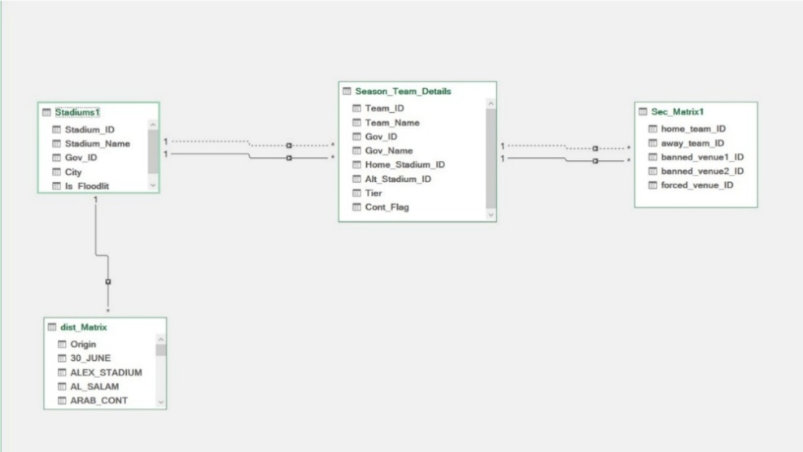
  - Infrastructure Model (Figure 1): We established a Many-to-One relationship between the Teams table (Season_Team_Details) and the Stadiums table. Additionally, the Distance Matrix was linked to the Stadiums table, ensuring that every venue has a calculated travel cost to every other venue.

Figure 1: Team & Stadiums Relation Diagram

  - Temporal Model (Figure 2): We created a "Star Schema" around the Expanded_Calendar table. By linking the FIFA_DAYS and CAF_Dates tables to the master Day_ID, the system can automatically flag specific time slots as "Blocked" without manual entry, ensuring that no domestic match is ever scheduled during a confirmed international window.
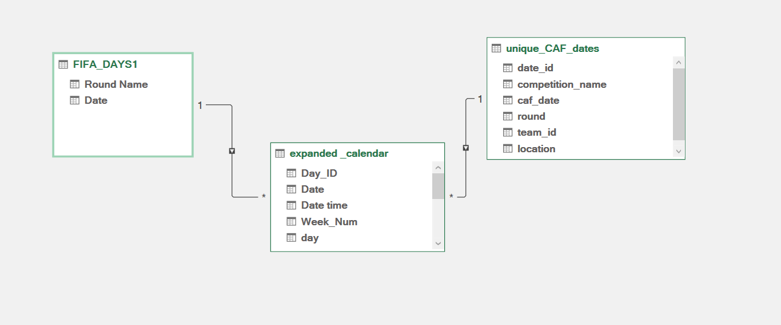

Figure 2:Dates Relationship Model
- Data Integrity: The data was largely used in its original form. Complex cleaning algorithms were not required; instead, the focus was on ensuring that the constraints (such as stadium capacities and security rules) were accurately represented in the Excel sheets.

CHAPTER 3B

MATHEMATICAL FORMULATION

Sets
Symbol | Definition
M | Set of all matches, |M| = 306
S | Set of all usable (non-FIFA) calendar slots, |S| approx 824
T | Set of all teams, |T| = 18
V | Set of all stadiums, |V| = 22
R | Set of round numbers {1, 2, ..., 34}
C ⊆ T | Set of CAF-participating teams (Cont_Flag ∈ {CL, CC})
T1 ⊆ T | Set of Tier-1 teams (league tier = 1)
W | Set of all calendar week numbers in the season
D | Set of all calendar dates in the season
Table 8: Sets

Parameters

Match parameters
Symbol | Definition
team(m) | Set contains the home and away team for match m ∈ M
home(m) | Home team of match m
away(m) | Away team of match m
tier_match(m) | Quality tier in {1,2,3} of match m
round(m) | Abstract round number of match m in {1,...,34}
is_derby(m) | 1 if home(m) in T1 and away(m) in T1, else 0 (needed by H2)
Table 9: Match Parameters

Slot parameters
Symbol | Definition
date(s) | Calendar date of slot s in S
week(s) | Calendar week number of slot s in S
tier_slot(s) | Quality tier in {1,2,3} of slot s (function of day-of-week and kickoff hour)
time_index(s) | Non-negative integer encoding the chronological position of slot s
kickoff_hour(s) | integer hour (0–23) of kickoff time of slot s ∈ S
Table 10: Slot Parameters

Round parameters
Symbol | Definition
nominal_week(r) | Ideal calendar week for round r, computed by linear interpolation across the season
Table 11: Round Parameters

CAF parameters
Symbol | Definition
caf_dates(t) | Sorted list of CAF match dates for team t in C
CAF_BUFFER | Minimum calendar days apart from any CAF date = MIN_REST_DAYS_CAF + 1 = 4
Table 12: CAF Parameters

Capacity constants
Constant | Value and meaning
MAX_DAY | 3 max league matches on one calendar date
MAX_SLOT | 2 max simultaneous matches in the same kickoff slot
HARD_MAX_WEEK | 18 hard upper bound on matches per calendar week
SOFT_MIN_WEEK | 6 soft lower targets for matches per calendar week
SOFT_MAX_WEEK | 12 soft upper targets for matches per calendar week
REST_LOCAL | 4 min calendar days between consecutive league matches
MAX_STREAK | 2 max consecutive home (or away) matches
Table 13: Capacity Constants

Venue Parameters
Symbol | Definition
is_forced(m,v) | 1 if venue v is security-mandated for match m, else 0
is_primary(m,v) | 1 if v is the home team’s primary stadium, else 0
is_alt(m,v) | 1 if v is the home team’s alternate stadium, else 0
is_other(m,v) | 1 if v is neither primary nor alternate (and not banned), else 0
disp_km(m,v) | distance in km from the home team’s primary stadium to venue v
travel_km(m,v) | distance from the away team’s home stadium to venue v
Table 14: Venue Parameters

Feasible Domain
Let feasible_domain(m) be the subset of S that match m is permitted to use before the solver runs. A slot s belongs to feasible_domain(m) if and only if all the following hold:
(FD-1) date(s) is not in FIFA_DATES
(FD-2) date(s) has valid date, week, and kickoff metadata
(FD-3) For each t in team(m) intersect C, for each d in caf_dates(t):
|date(s) - d| >= CAF_BUFFER (= 4 days)
Constraints H3-H11 are enforced inside the CP-SAT model and are not applied at domain-construction time.

Decision Variables

Primary assignment
x[m,s,v] in {0,1}, for all m in M, s in feasible_domain(m), v in VenueCandidates
x_{m,s,v} ∈ {0, 1}, ∀ m ∈ M, s ∈ feasible_domain(m), v ∈ VenueCandidates(m)
- x[m,s,v] = 1 if and only if match m is assigned to calendar slot s at venue v.

Auxiliary time variables
match_time[m] in Z+, for all m in M match_timeₘ ∈ ℤ⁺, ∀ m ∈ M
round_min[r] in Z+, for all r in z round_minᵣ ∈ ℤ⁺, ∀ r ∈ R
round_max[r] in Z+, for all r in R round_maxᵣ ∈ ℤ⁺, ∀ r ∈ R

Weekly load variables

load_w in Z+, for all w in W (total matches assigned to week w)
load_w ∈ ℤ⁺, ∀ w ∈ W
under_load_w in Z+, for all w in W (matches below soft minimum)
under_load_w ∈ ℤ⁺, ∀ w ∈ W
over_load_w in Z+, for all w in W (matches above soft maximum)
over_load_w ∈ ℤ⁺, ∀ w ∈ W

Final-Round Slot variables
fr_slots in {0,1}, for all s in feasible_domain restricted to Round 34
fr_slot_{s} ∈ {0,1}, ∀ s ∈ feasible_domain restricted to Round 34 matches

Collision Indicator Variables
slot_collisions in {0,1} (1 if more than one match occupies slot s)
overlap[v,d] in {0,1} (1 if venue v has two non-forced matches within SERVICE_GAP days of date d)
slot_collision_{s} ∈ {0,1}
overlap_{v,d} ∈ {0,1}

Hard Constraints
H1 - Assignment uniqueness
Sum_s in feasible_domain(m) x[m,s] = 1, or all m in M
∑ₛ xₘₛ = 1 ∀ m ∈ M
- Every match is assigned to exactly one slot.
H2 - Tier-1 derby slot requirement
Sum_{s in feasible_domain(m), tier_slot(s)=1} x[m,s] = 1,
for all m in M such that is_derby(m) = 1
∑ₛ∶ tier_slot(s)=1 xₘₛ = 1 ∀ m : is_derby(m)=1
- A match between two Tier-1 teams must be scheduled in a Tier-1 (prime-time) slot.
H3 - Team date uniqueness
Sum_{m: t in team(m)} Sum_{s: date(s)=d} x[m,s] <= 1,
for all t in T, d in D
∑ₘ∶t ∈ team(m) ∑ₛ∶date(s)=d xₘₛ ≤ 1 ∀ t ∈ T, d ∈ D
- Each team plays at most one league match per calendar date.

H4 - Venue slot uniqueness
Sum_{m in M} x[m,s,v] <= 1, for all v in V, s in S
Σ_{m∈M} x_{m,s,v} ≤ 1, ∀ v ∈ V, ∀ s ∈ S
- Each venue hosts at most one match per kickoff slot.
H5 - Daily match cap
Sum_m Sum_{s: date(s)=d} x[m,s] <= MAX_DAY,for all d in D
∑ₘ ∑ₛ∶date(s)=d xₘₛ ≤ MAX_DAY ∀ d∈D
- At most MAX_DAY = 3 league matches may be scheduled on any one calendar date.
H6 - Slot concurrency cap
Sum_m x[m,s] <= MAX_SLOT, for all s in S
∑ₘ xₘₛ ≤ MAX_SLOT ∀ s∈S
- At most MAX_SLOT = 2 matches may share the same exact kickoff slot.
H7 - Team rest (sliding 4-day window)
Sum_{m: t in team(m)} Sum_{s: date(s) in [d, d+3]} x[m,s] <= 1,for all t in T, d in D
∑ₘ∶t ∈ team(m) ∑ₛ∶date(s)∈[d, d+REST_LOCAL−1] xₘₛ ≤ 1 ∀ t ∈ T, d ∈ D
- Each team may play at most one league match in any 4-day window [d, d+3]. This guarantees a minimum of 3 full rest days between consecutive matches.
H8 - match_time definition
match_time[m] = Sum{s in feasible_domain(m)} time_index(s) * x[m,s], for all m in M
match_timeₘ = ∑ₛ∈feasible_domain(m) time_index(s)·xₘₛ ∀ m∈M
match_date[m] = Sum_{s in feasible_domain(m)} date_index(s) * x[m,s], for all m in M
match_dateₘ= ∑ₛ∈feasible_domain(m) date_index(s) ·xₘₛ ∀ m ∈ M

- Because exactly one x[m,s] equals 1, match_time[m] equals the chronological index of the chosen slot.
H9 - Round min/max definition
round_min[r] = min_{m: round(m)=r} match_time[m], for all r in R
round_max[r] = max_{m: round(m)=r} match_time[m], for all r in R
round_minᵣ = minₘ∶round(m)=r match_timeₘ ∀ r∈R
round_maxᵣ = maxₘ∶round(m)=r match_timeₘ
- Earliest and latest time-index for each round.
H10 - Strict round ordering
round_max[r] + MIN_ROUND_GAP <= round_min[r+1], for all r in {1, 2,..., 33}
round_max_{r} + MIN_ROUND_GAP ≤ round_min_{r+1}, ∀ r ∈ {1, 2, …, 33}
- All matches of round r must finish strictly before the first match of round r+1. The constraint is enforced on date indices (one calendar-day gap), not raw time indices.
H11 - Weekly hard cap
Sum_m Sum_{s: week(s)=w} x[m,s] <= HARD_MAX_WEEK, for all w in W
∑ₘ ∑ₛ∶week(s)=w xₘₛ ≤ HARD_MAX_WEEK ∀ w ∈ W
- At most HARD_MAX_WEEK = 18 league matches may be scheduled in any calendar week.

H12 - CAF buffer
Sum_{s in feasible_domain(m): |date(s)-d| < CAF_BUFFER} x[m,s] = 0, for all m in M, t in team(m) intersect C, d in caf_dates(t)
∑ₛ∶|date(s)−d|<CAF_BUFFER xₘₛ = 0 ∀ m ∈ M, t ∈ team(m)∩C, d ∈ caf_dates(t)
- A match involving a CAF-participating team may not be scheduled within CAF_BUFFER = 4 calendar days of that team's CAF match date. The buffer is bidirectional - it applies both before and after the CAF date.
H13 - Home/away streak limit
For all t in T, for all r in {1,...,32}:
Number of consecutive home (or away) matches starting at round r <= MAX_STREAK
Streakʰ(t,r) ≤ MAX_STREAK ∀ t∈T, r∈R
- No team may have more than MAX_STREAK = 2 consecutive home or away matches.
H14 - Final-Round Simultaneous Kickoff Slot
Sum_{s in FR_SLOTS} fr_slots = 1
Sum_{v} x[m,s,v] = fr_slots, for all m in M: round(m)=34, s in FR_SLOTS
Σ_{s∈FR_SLOTS} fr_slot_{s} = 1
Σ_{v} x_{m,s,v} = fr_slot_{s}, ∀ m ∈ M: round(m)=34, ∀ s ∈ FR_SLOTS
- All Round 34 matches must share exactly one kickoff slot s
H15 — Final-Round Single Calendar Date
Sum_{m: round(m)=34, v} x[m,s,v] <= MATCHES_PER_ROUND * fr_slots, for all s in FR_SLOTS
Σ_{m: round(m)=34, v} x_{m,s,v} ≤ MATCHES_PER_ROUND · fr_slot_{s}, ∀ s ∈ FR_SLOTS
- Because of H14, all Round 34 matches also share one calendar date. The daily cap is relaxed for that date

Objective Function
Minimize the weighted penalty sum:
Z = Z1 + Z2 + Z3 + Z4 + Z5 + Z6 + Z7 + Z8
Z1 - Round placement deviation:
Z1 = W_ROUND_ORDER * Sum_m Sum_{s in feasible_domain(m)}
|week(s) - nominal_week(round(m))| * x[m,s]
Z₁ = W_ROUND_ORDER · ∑ₘ∈M ∑ₛ ∈ feasible_domain(m) | week(s) − nominal_week(round(m)) | · xₘₛ
Z2 - Weekly underload penalty:
Z2 = W_WEEK_UNDERLOAD * Sum_{w in W} under_load_w
Z₂ = W_WEEK_UNDERLOAD · ∑ᵤ∈W under_load_w
Z3 - Weekly overload penalty:
Z3 = W_WEEK_OVERLOAD * Sum_{w in W} over_load_w
Z₃ = W_WEEK_OVERLOAD · ∑ᵤ∈W over_load_w
Z4 - Travel distance:
Z4 = W_TRAVEL * Sum_m Sum_{s in feasible_domain(m)} travel_km(m) * x[m,s]
Z₄ = W_TRAVEL · ∑ₘ∈M ∑ₛ∈feasible_domain(m) travel_km(m) · xₘₛ
Z5 - Tier mismatch:
Z5 = W_TIER_MISMATCH * Sum_m Sum_{s in feasible_domain(m)}
|tier_match(m) - tier_slot(s)| * x[m,s]
Z₅ = W_TIER_MISMATCH · ∑ₘ∈M ∑ₛ∈feasible_domain(m) | tier_match(m) − tier_slot(s) | · xₘₛ

Z6 - Evening preference:
Z6 = W_EVENING_PREFERENCE * Sum_{m in M} Sum_{s,v} max(0, 21 - kickoff_hour(s)) * x[m,s,v]
Z₅ = W_EVENING_PREFERENCE · Σ_{m∈M} Σ_{s,v} max(0, 21 − kickoff_hour(s)) · x_{m,s,v}
Z7 - Slot-spread penalty:
Z7 = W_SLOT_SPREAD * Sum_{s in S} slot_collisions
Z₇ = W_SLOT_SPREAD · Σ_{s∈S} slot_collision_{s}
Z8 - Non-primary venue penalty:
Z8 = W_STADIUM_MAINTENANCE_OVERLAP * Sum_{(v,d)} overlap[v,d]
Z₈ = W_STADIUM_MAINTENANCE_OVERLAP · Σ_{(v,d)} overlap_{v,d}
6.1 Weekly load auxiliary definitions
load_w = Sum_m Sum_{s: week(s)=w} x[m,s],for all w in W
load_w = ∑ₘ∈M ∑ₛ∶week(s)=w xₘₛ ∀ w ∈ W
The deviation variables are linearisations of the max(0, .) operator:
under_load_w >= SOFT_MIN_WEEK - load_w, under_load_w >= 0, for all w in W
under_load_w ≥ SOFT_MIN_WEEK − load_w ∀ w ∈ W
under_load_w ≥ 0 ∀ w ∈ W
over_load_w >= load_w - SOFT_MAX_WEEK, over_load_w >= 0, for all w in W
over_load_w ≥ load_w − SOFT_MAX_WEEK ∀ w ∈ W
over_load_w ≥ 0 ∀ w ∈ W
Since the objective minimises these variables, the solver sets:
under_load_w = max(0, SOFT_MIN_WEEK - load_w)
over_load_w = max(0, load_w - SOFT_MAX_WEEK)

Objective Weights
Weight | Value | Meaning
W_ROUND_ORDER | 100 | Penalty per week deviation from the nominal round week. Keeps rounds in expected calendar positions.
W_WEEK_UNDERLOAD | 50 | Penalty per match below SOFT_MIN_WEEK in any calendar week.
W_WEEK_OVERLOAD | 50 | Penalty per match above SOFT_MAX_WEEK in any calendar week.
W_TRAVEL | 1 | Penalty per km of away-team travel. Low weight; acts mainly as a tie-breaker.
W_TIER_MISMATCH | 20 | Penalty per tier level difference between match quality and slot quality.
W_EVENING_PREFERENCE | 50 | Per-hour penalty for kickoff before 21:00.
W_SLOT_SPREAD | 500 | Penalty per slot with more than one assigned match.
OVERLAP_PENALTY | 500 | Penalty per stadium service-gap violation.
Table 14: Objective Weights

Model Summary

Hard constraints
ID | Short description | Notes
H1 | Sum x[m,s,v] = 1 | Assignment completeness
H2 | Derby => tier-1 slot | is_derby flag
H3 | Team x date <= 1 | No double-booking per team per day
H4 | Venue x slot <= 1 | No stadium double-booking
H5 | Matches per day <= 3 | Daily match cap
H6 | Matches per slot <= 2 | Slot concurrency cap
H7 | 4-day sliding window <= 1 per team | 3 full rest days minimum
H8 | match_time and match_date definitions | Linear-combination auxiliary vars
H9 | round_min / round_max | Round-level time bounds
H10 | round_max[r] + MIN_ROUND_GAP ≤ round_min[r+1] | Strict chronological round ordering
H11 | Weekly load <= 18 | Hard weekly cap
H12 | CAF buffer exclusion | Bidirectional 4-day exclusion zone
H13 | Streak <= 2 | Enforced in fixture pre-solve
H14 | Round 34 shared kickoff slot | All 9 final-round matches in one slot
H15 | Round 34 single date | Daily cap relaxed to 9 for that date
,Table 15: Hard Constraints

Objective terms
Term | Description | Weight
Z1 | Round placement | 100
Z2 | Weekly underload | 50
Z3 | Weekly overload | 50
Z4 | Travel distance | 1
Z5 | Tier mismatch | 20
Table 16: Objectives
CHAPTER 4

SYSTEM DESIGN

System Architecture and Component Overview
The system is a single-process desktop/web application built on Streamlit. There is no client-server split, no database server, and no network API; everything – the UI, the solver, and the file outputs – runs inside the same Python process on the user's machine (or on Streamlit Community Cloud).

Layers
- Presentation layer – streamlit_app.py. Renders the sidebar controls, the five main tabs (Explore, Run & progress, Insights, Artifacts, Browse files), and reads back whatever CSV/JSON artifacts exist in output/ to populate charts and tables.
- Orchestration layer – main.py for the command-line path and the run_clicked block inside streamlit_app.py for the UI path. Both call the same underlying phase functions in the same order; the Streamlit version simply wraps each phase call in a worker thread so the progress indicators in the UI can update live.
- Domain / solver layer – src/data_loader.py, src/fixture_generator.py, src/slot_domain.py, src/baseline_solver.py, src/baseline_retry.py, src/output_writer.py, src/validation.py. This is where the actual scheduling logic lives, built around Google OR-Tools' CP-SAT constraint solver.
- Storage layer – plain files. Two Excel workbooks (Data_Model.xlsx, expanded_calendar.xlsx) are the inputs; everything the pipeline produces is written back out as CSV/JSON files under output/ and output/phases/. There is no relational database anywhere in the system.

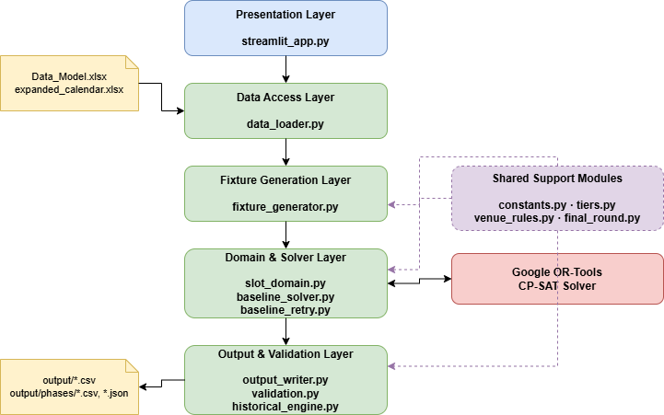
Component Diagram
Figure 3 : System Component Diagram

Deployment Architecture
The system is designed to run on a single machine (local or cloud). The Streamlit server is started with streamlit run streamlit_app.py and serves the browser UI over HTTP on localhost:8501 (or a cloud-assigned port). The CP-SAT solver (Google OR-Tools) runs in-process and uses the NUM_WORKERS constant to control the number of CPU threads it spawns. Monte Carlo batch runs use Python's ProcessPoolExecutor and the --parallel flag to utilise additional cores.

Class / Module Diagrams
The codebase favours small dataclasses and free functions over deep class hierarchies, which fits a constraint-programming pipeline where each phase is really a pure transformation: data in, a new structure out. The diagram below should be read as a module/dataclass diagram rather than a classical object-oriented class diagram with inheritance, since there is almost no inheritance in the project.
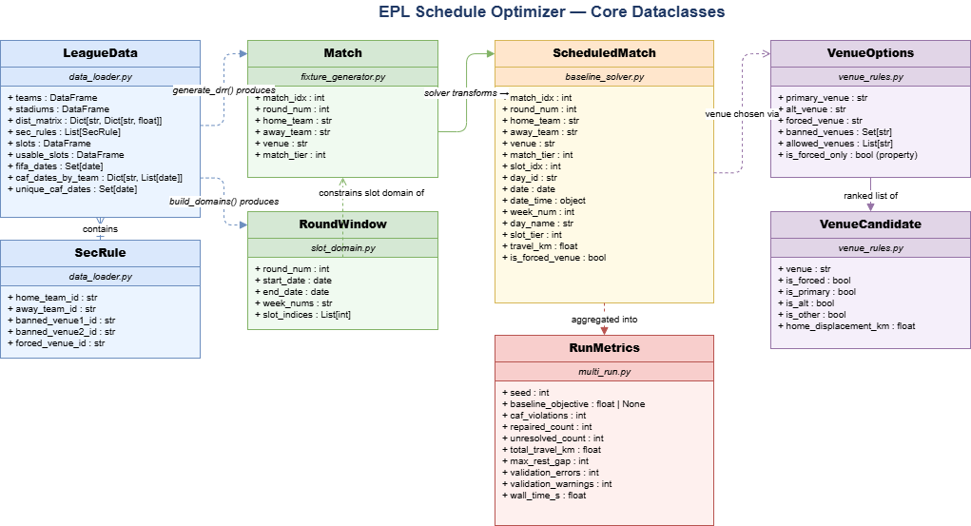
Figure 4 : Class Diagram

Key Data Structures Used by the Final Pipeline

LeagueData (src/data_loader.py)
The single object returned by load_data(). Holds everything the rest of the pipeline needs in memory: teams, stadiums, dist_matrix, sec_rules, slots, usable_slots, fifa_dates, caf_blockers, caf_dates_by_team, unique_caf_dates.

Match (src/fixture_generator.py)
One row of the fixture list before scheduling: match_idx, round_num, home_team, away_team, venue (the team's default home stadium unless a security rule forces another venue), and match_tier (derived from the two teams' league tiers).

RoundWindow (src/slot_domain.py)
A dataclass describing the calendar window allowed for one abstract round (start date, end date, the calendar weeks it touches, and the list of usable-slot row indices inside that window). The CAF-aware filtering is applied at this level.

ScheduledMatch (src/baseline_solver.py)
The output of the solver: a Match enriched with the concrete slot it was assigned (date, date-time, weekday, calendar week, slot tier), the venue used, the travel distance for the away team, and a flag for whether the venue was a forced security-rule venue. This is the structure that flows into output_writer.py and validation.py and is ultimately what the user sees in the Explore and Insights tabs.

RunMetrics (src/multi_run.py)
Used only by the batch/Monte-Carlo entry point. Summarises one solver run – objective value, total travel, CAF-related counts, validation error/warning counts – so many seeds can be compared and the best one re-materialised as the final schedule.

Sequence Diagrams (Key Use Cases)

Use Case: Run the Full Pipeline from the Streamlit UI
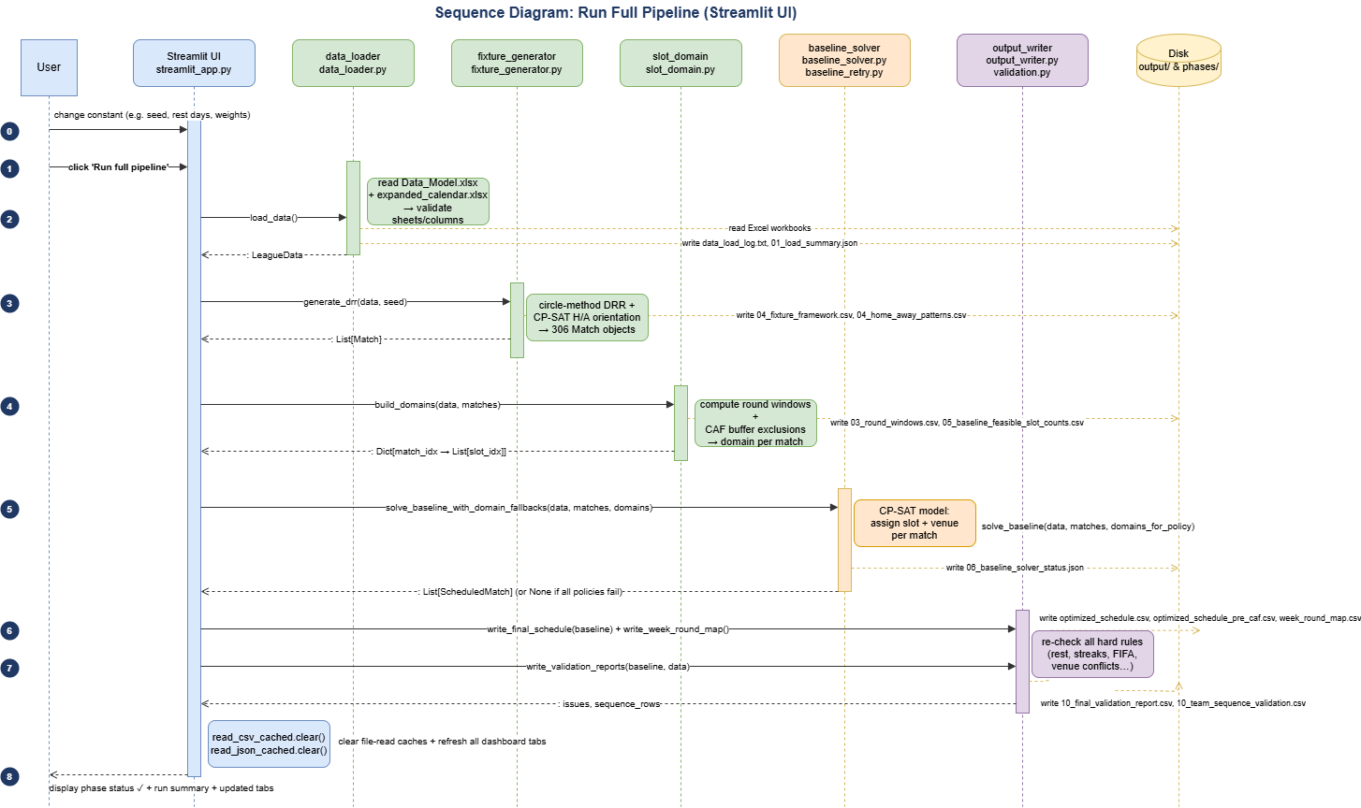
This is the main use case of the application – the user opens the app, optionally tweaks a constant in the sidebar, and clicks “Run full pipeline.”
Figure 5: Full Pipeline Use Case

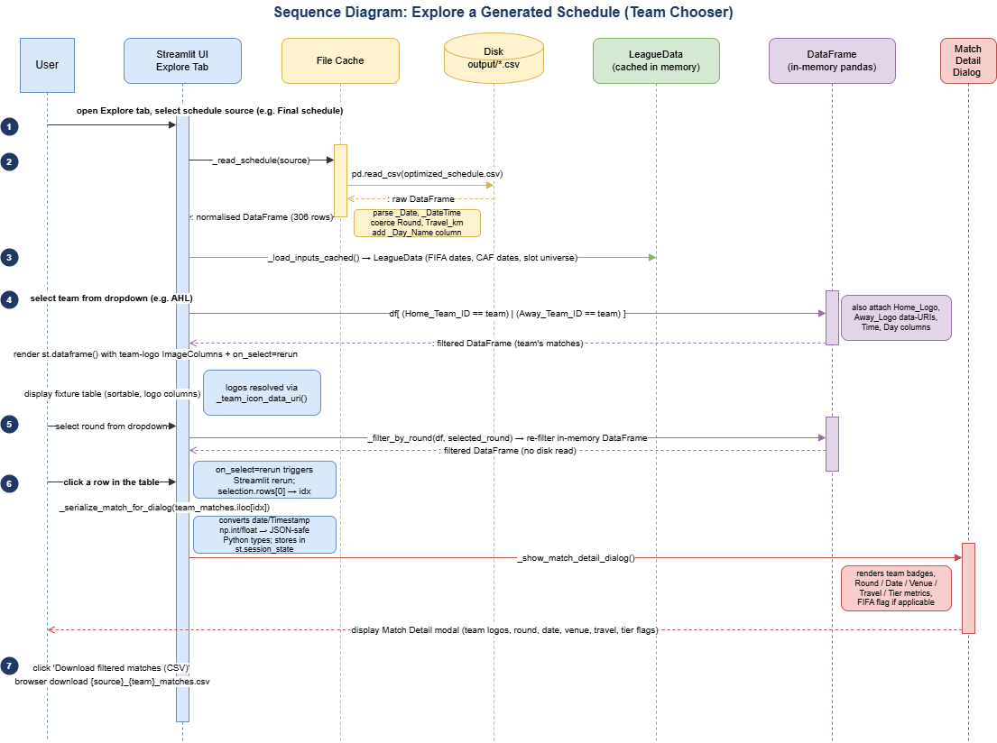
Use Case: Explore a Generated Schedule (Team Chooser)
Figure 6: Generated Schedule Use Case

Use Case: Inspect Schedule Quality (Insights Tab)
All six sub-tabs follow the same pattern: read one or more cached CSV/JSON artifacts, summarise them in a small pandas helper function, render an Altair bar chart with a click-selection, and show the underlying rows for whatever bar the user clicked. The Historical sub-tab additionally instantiates HistoricalEngine, which re-parses six seasons of real Egyptian Premier League CSV data from disk on every render (cached with @st.cache_data) purely for the side-by-side comparison chart against the optimizer's own numbers.
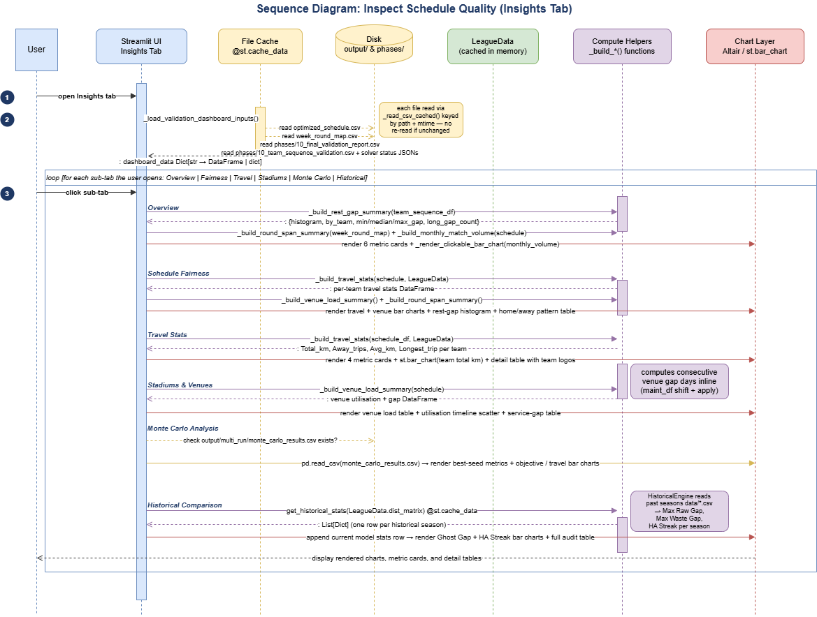
Figure 7: Explore Insights Use Case

CHAPTER 5
IMPLEMENTATION

I Implementation Environment and Setup

Language, Runtime, and Core Libraries
The whole project is written in Python 3 and organized as a src/ package imported by two entry points: main.py for command-line runs and streamlit_app.py for the interactive dashboard. The table below lists the third-party libraries the system depends on at runtime.
Library | Version family | Role in the project
ortools (cp_model) | OR-Tools CP-SAT | The constraint solver that assigns every match to a calendar slot and venue; also used for the small home/away-orientation model in fixture generation.
pandas / numpy | pandas 2 | All tabular data handling: reading the Excel workbooks, building the schedule DataFrame, and every aggregation shown in the Insights tab.
streamlit | 1.3 | The web UI framework the whole dashboard is built on (tabs, widgets, caching decorators, st.dialog modals).
altair | 5 | Interactive, click-to-filter bar charts used throughout the Insights tab.
openpyxl | 3 | The Excel engine pandas uses under the hood to read Data_Model.xlsx and expanded_calendar.xlsx.
Table 17: Used Libraries

Project Layout
The repository is organized so that source code, input data, and generated output never mix:
project_root/
├── main.py # CLI entry point
├── streamlit_app.py # Dashboard entry point
├── src/
│ ├── constants.py # every tunable rule and file path
│ ├── data_loader.py # Excel ingestion + validation
│ ├── fixture_generator.py # double round-robin (DRR) generation
│ ├── slot_domain.py # round windows + feasible-slot domains
│ ├── baseline_solver.py # CP-SAT calendar/venue assignment
│ ├── baseline_retry.py # domain-fallback retry wrapper
│ ├── output_writer.py # writes optimized_schedule.csv etc.
│ ├── validation.py # post-solve hard-rule checks
│ ├── historical_engine.py # benchmark vs. real EPL seasons
│ ├── tiers.py, venue_rules.py, final_round.py
│ └── multi_run.py # Monte Carlo batch runner
├── data/
│ ├── Data_Model.xlsx
│ └── expanded_calendar.xlsx
├── past seasons data/ # historical benchmark CSVs
└── output/ # created at runtime, never committed
└── phases/

Running the Project
Two supported ways to run the optimizer, matching the two entry points:
- Dashboard: streamlit run streamlit_app.py — opens the browser UI described in Chapter 4; the user sets the seed and any constant overrides in the sidebar and clicks “Run full pipeline.”
- Command line / batch: python main.py --seed 88 --runs 1 for a single deterministic run, or --runs N (with --parallel workers) to launch a Monte Carlo sweep across N seeds via multi_run.py, checkpointing progress to output/multi_run/monte_carlo_results.csv after every completed seed.
Both entry points expect Data_Model.xlsx and expanded_calendar.xlsx to already exist at the paths declared in constants.py (DATA_MODEL_PATH, EXPANDED_CALENDAR_PATH). There is no installer or setup wizard; a working Python environment with the libraries in Table 5.1 installed is the only prerequisite.

Key Implementation Details

Fixture Generation: Circle Method + CP-SAT Orientation
The 306-match double round-robin is built in two stages inside fixture_generator.py. First, the classic circle method produces 17 rounds of unordered pairings for a shuffled team list (one team fixed, the other 16 rotating around it each round) this guarantees every team meets every other team exactly once in the first leg. Second, because the circle method does not decide who is home and who is away, a small CP-SAT model (_solve_orientation) assigns a home/away orientation to every first-leg pairing so that, across the full 34-round season, no team exceeds a 3-window / 5-window home-away balance (no more than 2 home or away games in any 3 consecutive rounds, and a 2–3 split in any 5-round rolling window). The second leg simply mirrors the first leg with home and away swapped.
The orientation solve is attempted with three progressively looser rule sets (orient_pairings_with_valid_patterns): first with the rolling-5 balance rule and balanced season edges, then without balanced edges, and finally without the rolling-5 rule at all if the first two attempts fail within their 15-second time budget. This mirrors the same “try strict, fall back to looser” philosophy used later in the baseline solver.

Slot Domains and the CAF Rest-Day Rule
Before the main solve, slot_domain.py builds 34 chronological round windows from the usable (non-FIFA) calendar slots, then computes, for every match, the specific list of slot indices it is allowed to use — its domain. This is also where the CAF rest-day rule is enforced. The _build_blocked_by_team pre-computes, for every CAF-participating team, the set of calendar slots that fall within MIN_REST_DAYS_CAF + 1 days of one of that team's continental fixtures, and those slots are simply excluded from the match's domain before the solver ever runs. Because the CP-SAT decision variable for a match/slot pair is only created for slots inside that match's domain, a CAF violation is not something the solver has to be told to avoid — it is a value the variable cannot take in the first place. If excluding every CAF-blocked slot would leave a match with zero playable slots in its round window, the buffer is relaxed for that single match rather than making the whole round infeasible, and the match is flagged in 05_baseline_feasible_slot_counts.csv (caf_filter_relaxed_for_repair column) purely for diagnostic visibility.
Round windows themselves are also adaptive. If a round's compact 5-day window has too few feasible slots for its 9 matches, _expand_non_final_round_windows grows that specific round's window one day at a time (never touching the strict monotonic ordering between rounds) until either the slot count and per-match feasibility thresholds are met or the window hits its policy-defined ceiling.

The Baseline CP-SAT Model
baseline_solver.py builds one CP-SAT model per run. Each match/slot/venue combination inside the match's domain becomes a boolean decision variable; exactly one must be true per match. The hard constraints layered on top are:
- Rest days: no two matches for the same team fall within MIN_REST_DAYS_LOCAL days of each other (checked with a sliding date window per team, not just consecutive matches).
- Home/away and daily/weekly capacity: at most MAX_MATCHES_PER_DAY matches share a calendar date, at most MAX_MATCHES_PER_SLOT share a kickoff slot, and weekly load stays under HARD_MAX_MATCHES_PER_WEEK.
- Round ordering: the latest match of round N must fall at least MIN_DAYS_BETWEEN_ROUNDS days before the earliest match of round N+1, modeled with auxiliary per-round min/max day variables
- Venue conflicts: no venue hosts two matches in the same slot, and (when MIN_STADIUM_SERVICE_GAP_DAYS > 0) back-to-back use of the same non-forced venue within the service-gap window is penalized rather than forbidden outright, via an overlap indicator variable added to the objective.
- Tier-1 derbies: any match between two Tier-1 clubs must land in a Tier-1 (weekend-evening) kickoff slot, enforced as a hard sum-equals-one constraint over that match's Tier-1 slot variables.
- Final-round single-slot rule: every Round 34 match is forced onto one shared calendar date and kickoff slot across the whole league, implemented by aggregating each match's per-slot indicator variables into one shared boolean per candidate slot and requiring exactly one candidate slot to be chosen league-wide.
On top of these hard constraints, a single weighted linear objective is minimized — round-order drift, week under/overload, travel distance, match-tier vs. slot-tier mismatch, evening-kickoff preference, slot-spread (discouraging clustering multiple matches in one kickoff slot on the same day), and the venue-relief penalties described above. All weights live in constants.py (W_ROUND_ORDER, W_TRAVEL, W_TIER_MISMATCH, and so on) and are exposed as sliders in the Streamlit sidebar.

Domain-Fallback Retries and the Final-Round Rescue Model
A model this constrained can be infeasible under its strict round-window policy. baseline_retry.py wraps the solve in a three-attempt loop — compact windows, then extended “EPL-style” spillover windows, then full-season spillover tails — rebuilding domains and re-solving each time until one attempt returns a schedule or all three are exhausted.
A second, more targeted fallback exists specifically for Round 34. Because the final round is forced onto a single shared slot league-wide, it is disproportionately likely to be the reason a solve fails even when Rounds 1–33 are easy. When the strict combined model is infeasible (or its final-round shared-slot constraint has no viable candidate slot at all), the solver instead solves Rounds 1–33 alone first, then builds a dedicated, much smaller CP-SAT model that fixes those 297 matches and searches only for a common slot and venue set for the remaining 9 final-round matches. In this rescue model, rules that were hard constraints in the main solve (rest-day buffers, tier-1 slot requirement, round-gap spacing, weekly caps, forced-venue rules) become penalized soft violations instead, each with its own weight (FINAL_ROUND_RESCUE_*_PENALTY constants), so the model can still return a usable, ranked-best schedule even in a genuinely tight calendar rather than failing outright.

Post-Solve Validation
Once a schedule is produced, validation.py re-checks every hard rule end-to-end — rest gaps, home/away streaks, round ordering, FIFA-date exclusion, CAF buffers, venue/slot conflicts, and the final-round rule — and writes a pass/fail report (10_final_validation_report.csv) plus a per-team match sequence (10_team_sequence_validation.csv) that the Insights tab reads directly. This stage is deliberately read-only: unlike the CAF-repair pass from an earlier version of the project, it does not move any match. Its only job is to give an honest, independent confirmation that the constraints the solver was asked to satisfy were in fact satisfied, which also makes it useful as a regression check whenever a constant in constants.py changes.

Streamlit Application: Caching and Non-Blocking Runs
Two implementation problems are specific to wrapping a multi-minute CP-SAT solve inside a reactive web UI: keeping the page responsive while the solver runs, and avoiding repeated, expensive file reads every time the user clicks something unrelated (Streamlit reruns the whole script on every interaction).
For responsiveness, _run_phase in streamlit_app.py runs each pipeline phase on a background thread and polls it from the main thread with thread.join(timeout=0.2), so Streamlit keeps servicing its websocket connection instead of freezing for the full duration of a phase. Standard output and standard error are captured with redirect_stdout / redirect_stderr into an in-memory buffer, which the main thread tails into the “Live stdout” panel only when the “Show live logs” toggle is on.
For caching, two layers are used: st.cache_resource around load_data() so the (relatively expensive) Excel parse only happens once per session, and st.cache_data around every CSV/JSON reader, keyed on a (path, modification-time) tuple rather than the path alone — so a file that has not changed since the last read is served from cache, but a freshly re-run pipeline invalidates the cache automatically because its output files get a new mtime. After a successful run, the app explicitly calls _read_csv_cached.clear() and _read_json_cached.clear() so the Explore and Insights tabs are guaranteed to reflect the new files on the very next rerun rather than waiting for an mtime check that could, in principle, race the filesystem.

Sample Screenshots / Output Samples
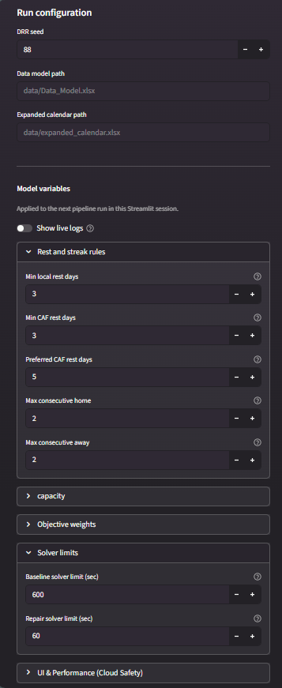
The screenshots below are captures of the running Streamlit application; the output sample that follows them is drawn directly from the real column layout the pipeline writes.
Figure 8: Sidebar

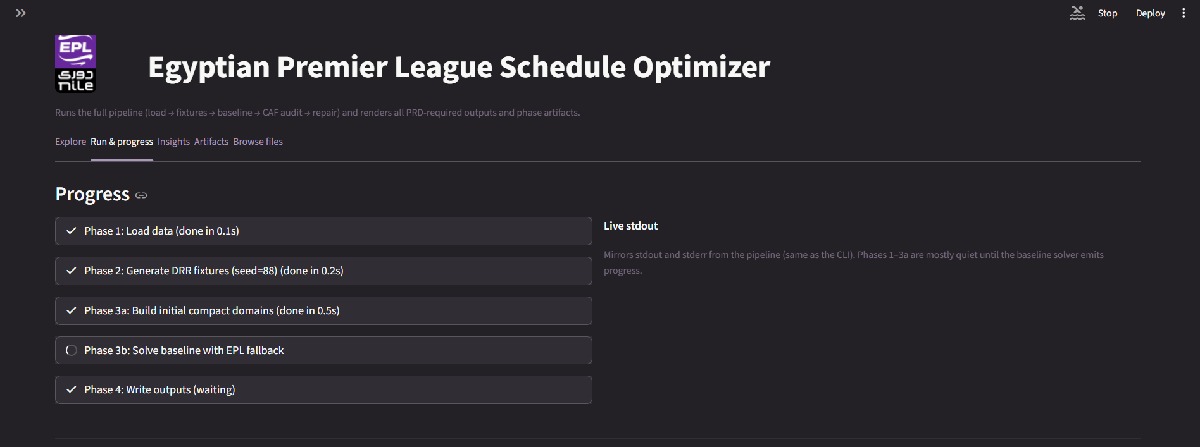
Figure 9: “Run & progress” tab mid-run
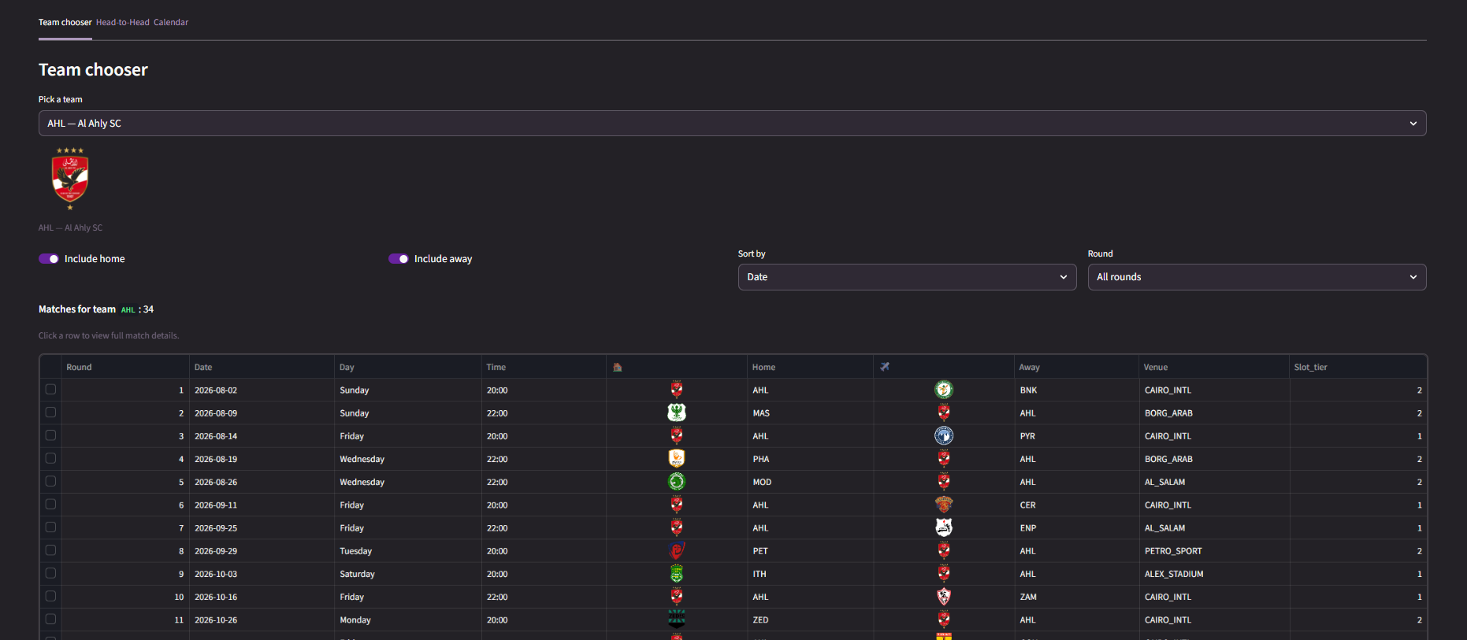
Figure 10: “Explore” tab — Team chooser

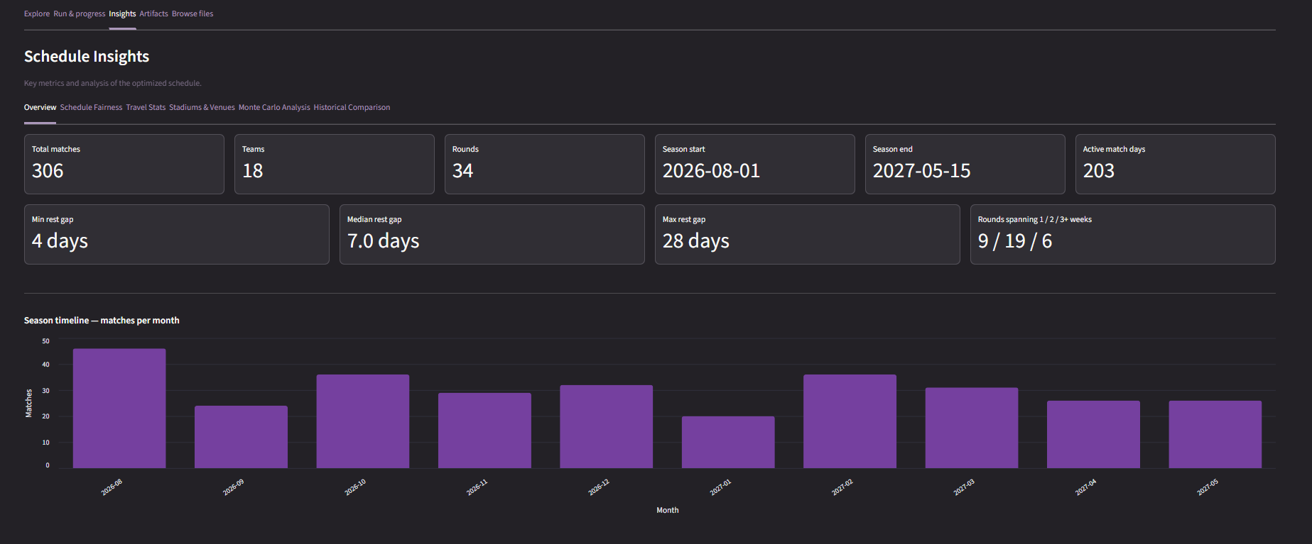
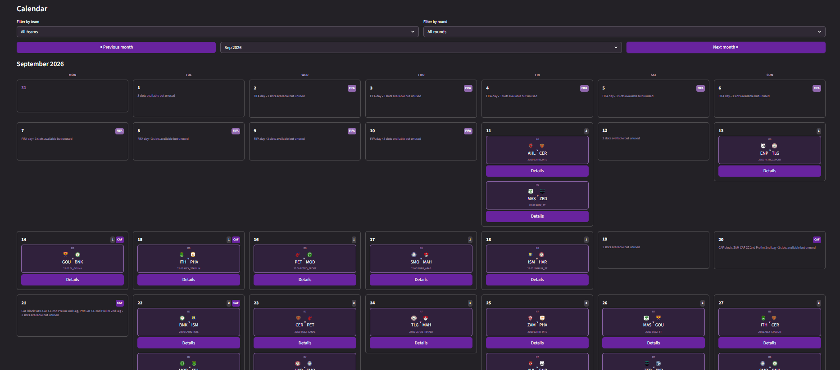
Figure 11: “Insights” tab — Overview sub-tab
Figure 12: “Explore” tab — Calendar sub-tab

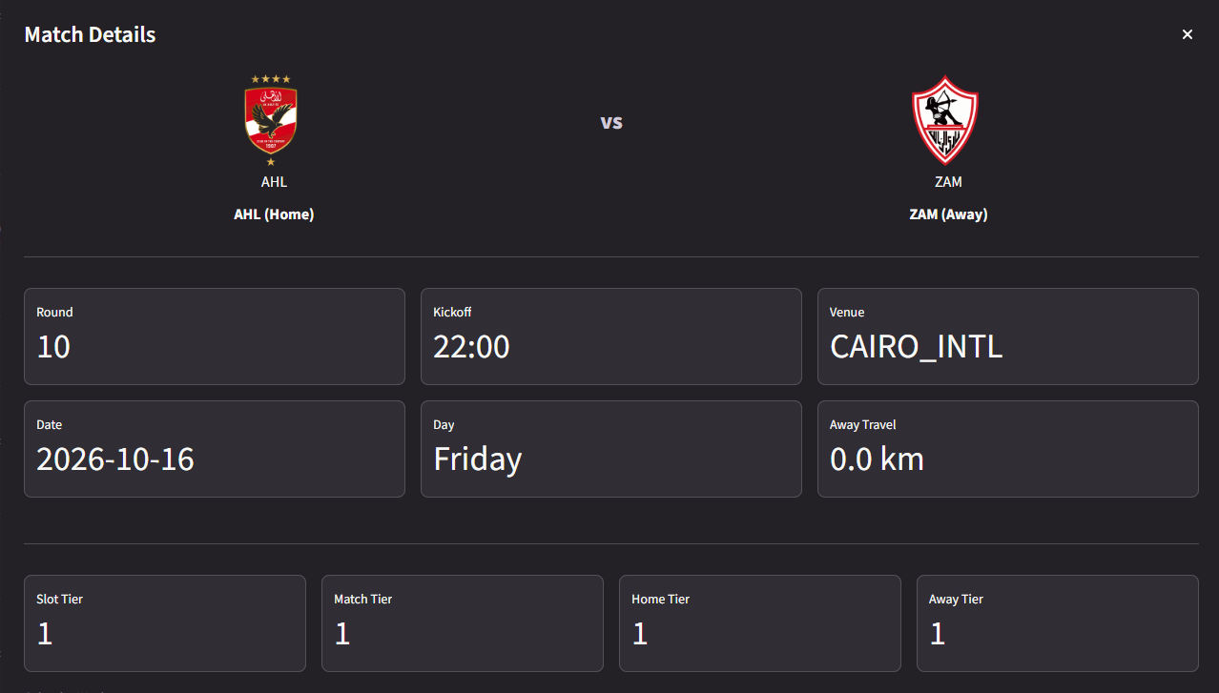
Figure 13: Match Details Card

Final Schedule Output (optimized_schedule.csv)

output_writer.py writes following columns for every scheduled match, sorted by date and then round. This is the file all tabs and download buttons in the Explore/Artifacts tabs reads from.
Column | Example value | Column
Round | 17 | Home_Team_ID
Calendar_Week_Num | 23 | Away_Team_ID
Day_ID | D_20260218 | Venue_Stadium_ID
Date | 2026-02-18 | Travel_km
Date_time | 2026-02-18 20:00 | Slot_tier
Match_Tier | 1 | Is_FIFA / Is_CAF
Postponed | False | Postponement_Status / Reason
Figure 14: Output Format

CHAPTER 6
TESTING AND EVALUATION

Testing

Testing strategy
No separate pytest suite was written for this project. Instead, correctness was verified through four complementary mechanisms that are all part of the shipped pipeline itself, so every run of the application is, in effect, also a test run.

Build-Time Structural Assertions
fixture_generator.py calls _validate_drr immediately after generating the double round-robin, before the matches are ever handed to the solver. This function contains a series of plain Python assert statements that check the fixture list is structurally sound: exactly 306 matches, exactly 306 distinct ordered (home, away) pairs, every team playing exactly 17 home and 17 away matches, and exactly 9 matches per round with no team appearing twice in the same round. If any of these fail, the pipeline stops immediately with a Python AssertionError rather than silently continuing with a broken fixture list — this is the project's first line of defense and catches fixture-generation bugs before a single CP-SAT variable is created.

Automated Post-Solve Validation
After every solve, validation.py independently re-checks the finished schedule against every hard rule from the mathematical model in Chapter 3B — it does not trust that the solver's constraints were written or wired correctly, it re-derives each rule from the raw ScheduledMatch list and flags any row that violates it. This acts as the project's regression test: whenever a constant in constants.py is changed (a rest-day rule, a weekly cap, a weight), the very next run's 10_final_validation_report.csv shows immediately whether the change broke something. Because this check runs on every single execution, not on a separate manually triggered test command, it caught most of the edge-case bugs found during development (for example, an early version of the round-order check missed postponed matches and had to be corrected after the report surfaced repeated false positives during development).

Manual / Exploratory Testing via the Dashboard
The Streamlit “Artifacts” and “Browse files” tabs were used throughout development as an ad-hoc inspection tool: after any code change, a full run was triggered from the sidebar and the resulting CSVs were spot-checked directly in the browser rather than by opening the output folder in a separate file manager. This made the feedback loop between changing a constraint and seeing its effect on the schedule fast enough to be used as the primary day-to-day testing method.

Test Cases and Results
The table below lists checks validation.py performs on every run, presented as test cases
ID | Rule Tested | Method / Check Name | Severity | Result
TC-01 | Fixture completeness | FIXTURE_COUNT — 306 matches, both league phases present | ERROR | PASS
TC-02 | Ordered-pair completeness | ORDERED_PAIR_COUNT — every team meets every other team home and away | ERROR | PASS
TC-03 | FIFA date exclusion | FIFA_DATE — no league match falls on an international break date | ERROR | PASS
TC-04 | CAF rest buffer | CAF_BUFFER — CAF teams keep required days clear of continental fixtures | ERROR | PASS
TC-05 | Local rest days | TEAM_REST — minimum days between any team's consecutive matches | ERROR | PASS
TC-06 | Home/away streak cap | TEAM_HOME_AWAY_STREAK — no team exceeds the configured streak limit | ERROR | PASS
TC-07 | Rolling-5 balance | TEAM_ROLLING5_BALANCE — 2–3 home/away split in any 5-match window | WARN | PASS (0–2 warnings typical)
TC-08 | Round chronology (team) | TEAM_ROUND_ORDER — a team's non-postponed rounds stay in order | ERROR | PASS
TC-09 | Round chronology (league) | GLOBAL_ROUND_ORDER — round N finishes before round N+1 starts | ERROR | PASS
TC-10 | Daily match cap | DAILY_MATCH_CAP — at most MAX_MATCHES_PER_DAY league matches share a date | ERROR | PASS
TC-11 | Venue/slot conflicts | VENUE_SLOT_CONFLICT — no venue hosts two matches in one kickoff slot | ERROR | PASS
TC-12 | Stadium turnaround | STADIUM_SERVICE_GAP — non-forced venue reuse respects the service gap | WARN | PASS (occasional WARN on tight calendars)
TC-13 | Final-round rule | FINAL_ROUND_SINGLE_SLOT — all 9 Round-34 matches share one date/slot | ERROR | PASS
TC-14 | DRR structural integrity | _validate_drr asserts (pre-solve, fixture_generator.py) | ERROR (assert) | PASS
Table 18: Test Cases

Performance Evaluation / Benchmarking

Solver Performance
The baseline CP-SAT model is given a hard wall-clock ceiling (BASELINE_SOLVER_TIME_LIMIT_S, 600 seconds by default) per domain-policy attempt. In practice, most seeds solve to OPTIMAL or a good FEASIBLE solution well before this ceiling under the compact round-window policy; the looser epl_relaxed and epl_full policies are only reached — and only add to total run time — on seeds where the compact policy is genuinely infeasible.
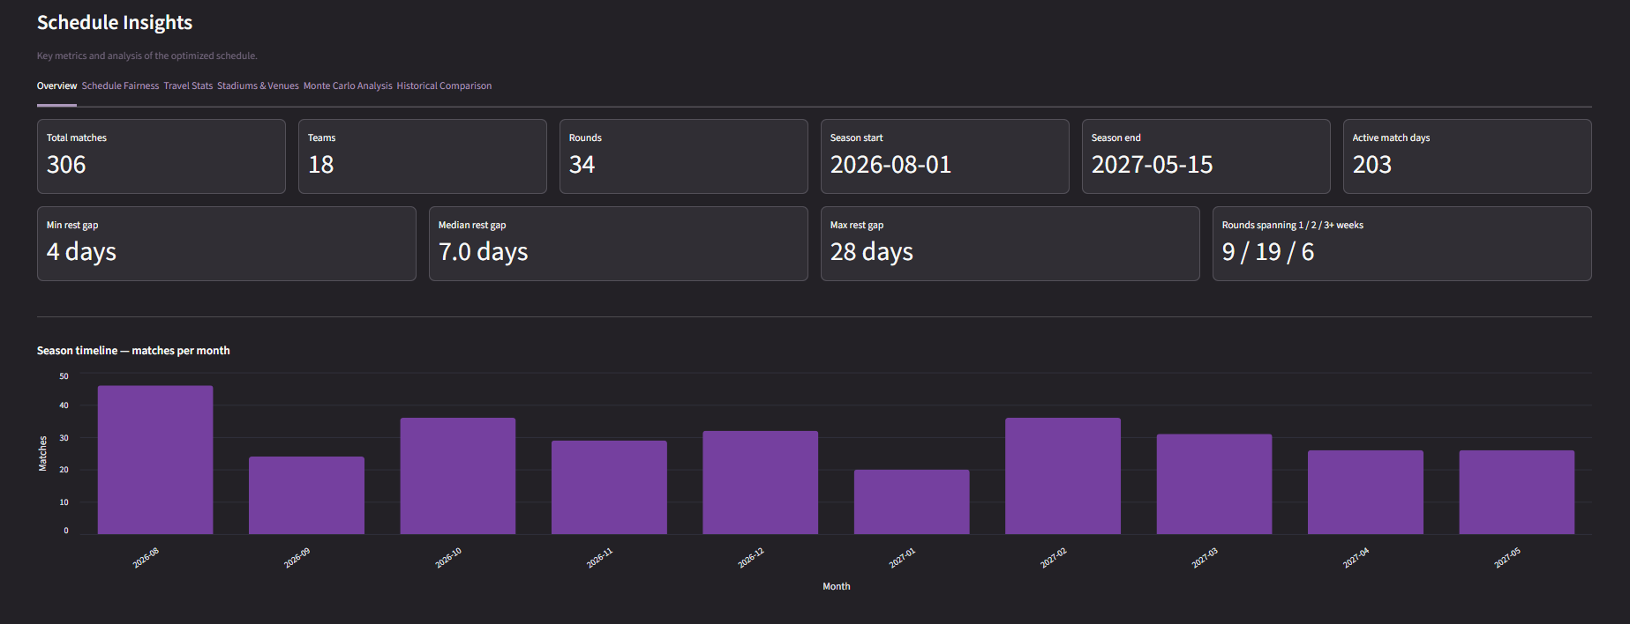
Figure 15: Results Overview

Evaluating Travel Efficiency
A primary objective of the optimization model is to reduce unnecessary travel fatigue for away teams, particularly for geographically distant clubs. The baseline solver achieves this through the W_TRAVEL penalty, which calculates the exact distance between the away team's home base and the assigned match venue using the origin-destination distance matrix.
By applying a per-kilometer penalty, the solver naturally favors scheduling assignments that minimize extreme cross-country travel within condensed timeframes. To validate the success of this objective, the Travel sub-tab inside the Insights dashboard aggregates the total travel distance for all 18 teams across the season.
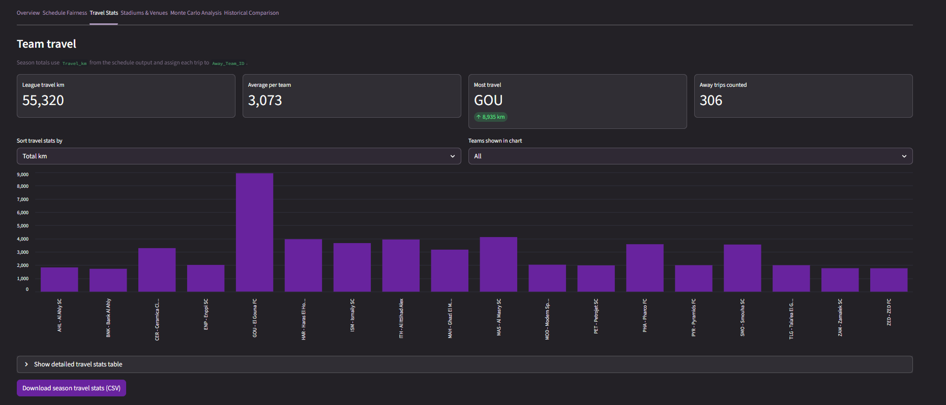
Figure 16: Travel Fairness Insights

Stadium Utilization and Maintenance Overlaps
The Egyptian Premier League relies heavily on shared venues. This creates a significant scheduling bottleneck. To manage this, the solver enforces a stadium service gap (MIN_STADIUM_SERVICE_GAP_DAYS), ensuring that the same pitch is not used on back-to-back days, which protects the infrastructure.
When multiple teams request the same stadium for the same calendar window, the solver evaluates the W_STADIUM_MAINTENANCE_OVERLAP penalty. The Maintenance sub-tab in the Insights dashboard visually validates this process.
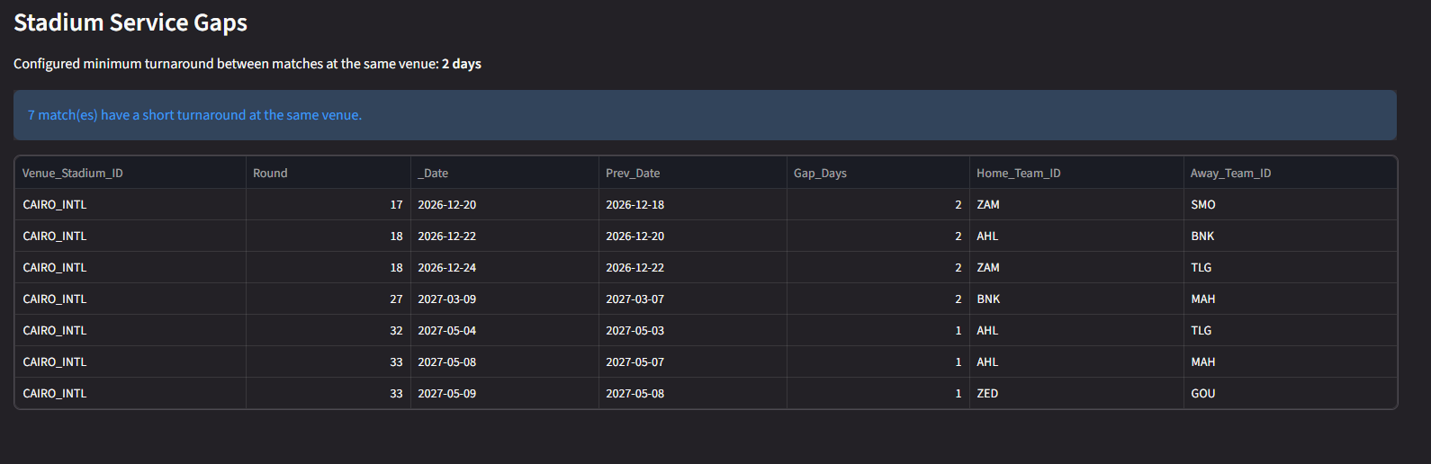
Figure 17: Stadium Service Gaps
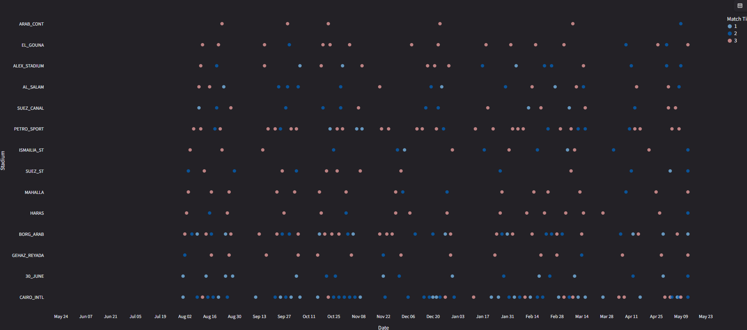
Figure 18: Venue Utilization Timeline
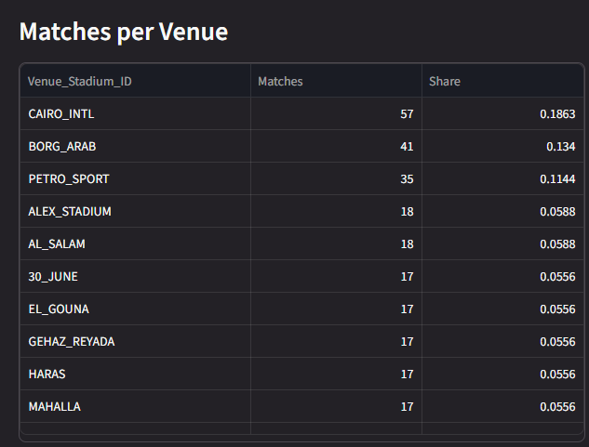
Figure 19: Matches per Venue:

Benchmarking Against Historical Seasons
The “Historical Comparison” sub-tab of Insights is the project's main built-in benchmarking tool. historical_engine.py re-derives, for six real Egyptian Premier League seasons, the same three headline metrics the optimizer itself is measured on: the maximum raw gap between a team's consecutive matches, the maximum ‘true waste gap’ (idle days once FIFA breaks and a CAF-match buffer are subtracted out), and the longest home/away streak any team was subjected to. The current model's own numbers are computed the same way from optimized_schedule.csv and appended as an extra row, so the comparison chart is built from one consistent methodology on both sides rather than mixing a strict metric for the model against a looser one for history.
This comparison is intentionally conservative in the historical direction: because the historical CSVs do not record which specific stadium a team used for a given home match, every historical fixture is assumed to be played at the team's primary stadium. The Insights tab documents this assumption directly to the user in an expandable “Methodology & Assumptions” panel .
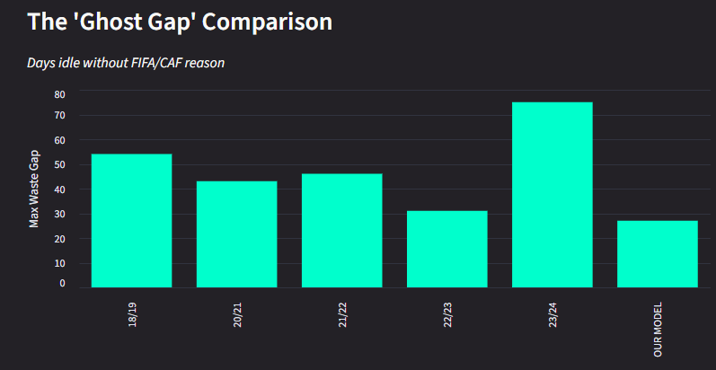
Figure 20: The 'Ghost Gap' Comparison
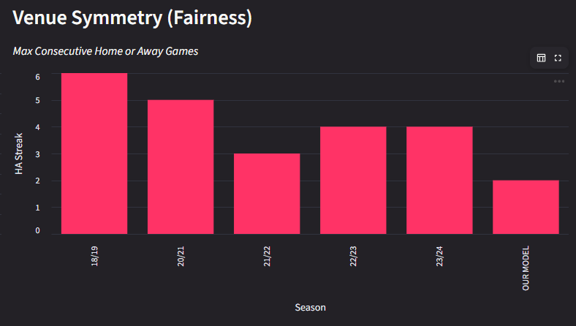
Figure 21: Venue Symmetry (Fairness)
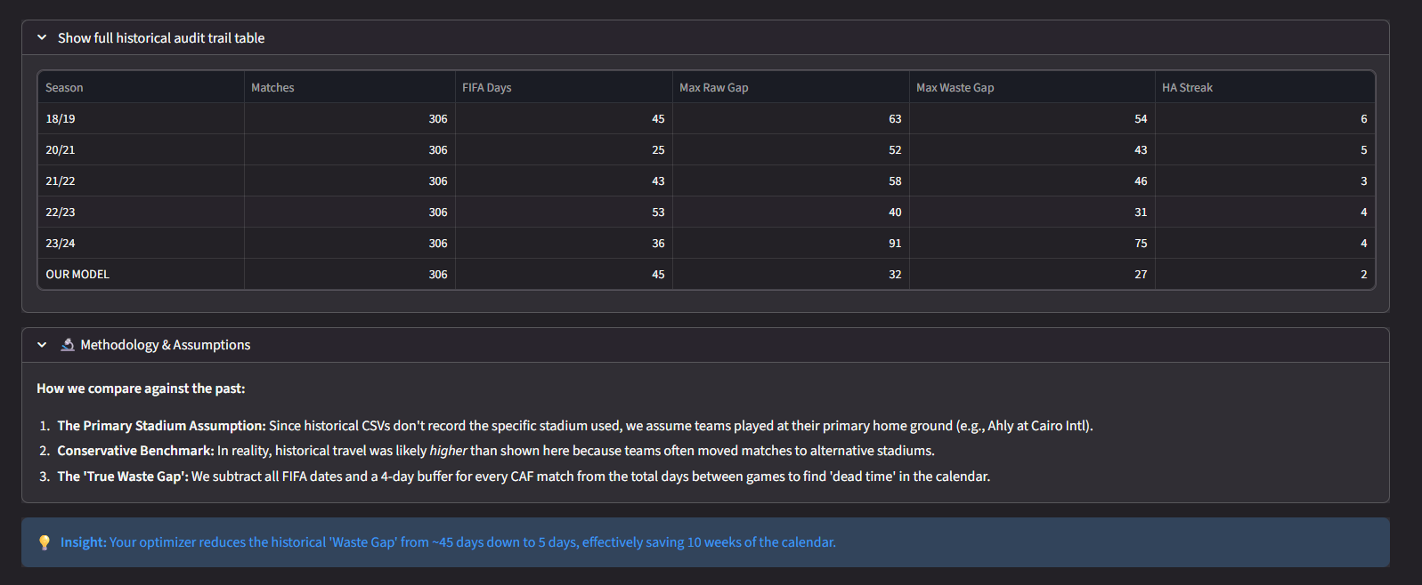
Figure 22: full historical audit trail table

Benchmarking Across Seeds (Monte Carlo)
Because a single DRR seed can, by chance, be harder or easier for the solver to schedule well, multi_run.py was used to sweep many seeds and rank them by the same priority order the app itself uses to pick a ‘best’ run: fewest validation errors first, then fewest unresolved matches, then lowest solver objective, then lowest total travel. The Monte Carlo sub-tab plots the resulting objective-value and travel-km distributions across the swept seeds.
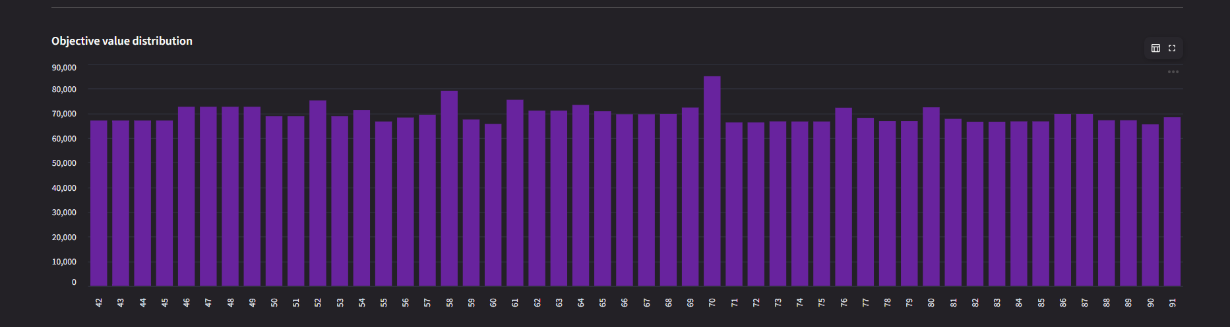
Figure 23: Monte-Carlo results

Limitations and Known Issues

Testing-Process Limitations
There is no automated unit-test suite (e.g. pytest) exercising individual functions in isolation, correctness relies fixture_generator.py and the end-to-end checks in validation.py

Application Limitations
- Solver feasibility is not guaranteed for arbitrary future calendars: if FIFA dates, CAF fixtures, and the venue/rest rules leave too little usable calendar, even the loosest domain-fallback policy and the final-round rescue model can fail.
- The Streamlit file cache is keyed on (path, modification time); on a filesystem with coarse mtime resolution, two writes to the same output file within the same time-resolution window are a theoretical (though not observed) source of stale reads.
- There is no authentication and no persistent audit trail of who ran which seed and when — acceptable for the project's single-user scope, but a limitation if the tool were ever exposed to multiple concurrent users.

CHAPTER 7
CONCLUSION AND FUTURE WORK

Conclusion

Summary of Achievements
The project set out to replace manual, spreadsheet-driven fixture scheduling for the Egyptian Premier League with a constraint-based optimizer, and delivered a working end-to-end system rather than a proof-of-concept notebook. Concretely, the finished application:
- Generates a complete, structurally valid 306-match double round-robin before the calendar solver ever runs.
- Assigns every match a concrete date, kickoff slot, and venue with a single CP-SAT model that enforces rest days, weekly load caps, daily/slot capacity, round ordering, tier-1 derby slot placement, and the final-round single-slot publication rule as hard constraints, while minimizing a weighted objective covering travel distance, round-order drift, kickoff-time preference, and venue-relief costs.
- Enforces the CAF continental-competition rest-day rule by excluding conflicting slots from a match's domain.
- Recovers automatically from an infeasible strict solve through a three-tier domain-fallback retry and a dedicated final-round rescue model.
- Independently re-validates every hard rule after the solve and writes a human-readable pass/fail report.
- Ships as a complete interactive Streamlit dashboard ,so a non-technical user can run the optimizer, inspect the result, and download every artifact without touching code.
- Benchmarks its own output against six real historical Egyptian Premier League seasons and, separately, across many random seeds via a Monte Carlo batch mode.
These pieces demonstrate that a constraint-programming approach is practical for a league of this size on ordinary hardware.

Lessons Learned

The Final Round Is a Source of Difficulty
Forcing all nine Round-34 matches onto one shared date and kickoff slot is a small requirement to state but a large one to satisfy, because it couples matches that would otherwise be scheduled independently. Treating the whole season, including Round 34, as one uniform CP-SAT model meant that a single hard-to-place final-round match could make the entire 306-match solve infeasible. Splitting the problem — solve Rounds 1–33 first, then solve a small, dedicated model for Round 34 with the same rules downgraded to penalized soft violations — was a direct response to watching this happen during development, and it is a reusable pattern: when one small, tightly-coupled part of a large constraint model is the recurring source of infeasibility, it is cheaper to carve it out into its own rescue model than to keep loosening the shared model's domains for everyone.

Real Data Is Messier Than the Model Assumes
A Huge share of implementation effort went into data_loader.py's sheet-name matching and column validation, and into the NAME_MAP dictionaries that reconcile inconsistent club-name spellings across historical season CSVs. None of this is visible in the mathematical model of Chapter 3B, but all of it was necessary before that model could run on real spreadsheets at all. We learned that the constraint model is often the easiest part to get right on paper, and the ingestion and normalization layer around it is where a project's real fragility happens.

Future Enhancements

Multi-objective Pareto optimization
The current solver uses a single weighted-sum objective. A Pareto front approach would let stakeholders visually trade off travel distance vs. tier-mismatch vs. rest-day quality instead of manually tuning the weights in constants.py.

Metaheuristic hybridization
Combine CP-SAT with a local search metaheuristic (e.g., Simulated Annealing, Tabu Search) to escape local optima and improve solution quality within the same time budget.

Weather and Ramadan awareness
Incorporate seasonal calendar events (e.g., Ramadan, extreme summer heat) as soft or hard constraints that affect kickoff time preferences or blackout periods.

Sensitivity analysis
Systematically measure how changes to individual constraint parameters (e.g., MIN_REST_DAYS_LOCAL, MAX_MATCHES_PER_DAY) impact solution quality and feasibility.

API layer
Expose the pipeline as a REST API so external systems (league management platforms, broadcasting schedulers) can trigger optimization runs and retrieve results programmatically.

League-agnostic configuration
Refactor the hardcoded 18-team, 34-round structure into a fully configurable input, making the tool usable for other leagues (e.g., Saudi Pro League, MLS, other African leagues).

Export to iCal/Google Calendar
Allow teams or fans to export their team's schedule as .ics calendar files.

References

[1] | R. V. Rasmussen and M. A. Trick, "Round robin scheduling – a survey," European Journal of Operational Research, 2008.
[2] | Ahram online, "EPL approve new format for Egyptian Premier League next season," 2024. [Online]. Available: https://english.ahram.org.eg/NewsContent/6/51/532092/Sports/Egyptian-Football/EPL-approve-new-format-for-Egyptian-Premier-League.aspx.
[3] | D. Van Bulck, D. Goossens and F. Spieksma, "Integer programming models for round robin tournaments," European Journal of Operational Research, 2023.
[4] | Ahram online, "Worn-out Egypt players in 'critical zone' due to congested schedules," 2022. [Online]. Available: https://english.ahram.org.eg/News/467780.aspx.
[5] | P. Staats, "Generic Scheduling of Sports Tournaments," Utrecht University, Utrecht, 2009.
[6] | D. R. Goossens and F. C. R. Spieksma, "Soccer schedules in Europe: an overview," Journal of Scheduling, vol. 15, no. 5, pp. 641-651, 2012.
[7] | K. Easton, G. Nemhauser and M. Trick, "The traveling tournament problem description and benchmarks," Principles and Practice of Constraint Programming, pp. 580-584, 2001.
[8] | G. Durán, M. Guajardo and J. Wolf-Yadlin, "Scheduling the Chilean soccer league by integer programming," Interfaces, vol. 37, no. 6, pp. 539-552, 2007.

